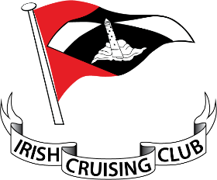

Unique Mandate Reference
Unique Mandate Reference (UMR) – to be completed by IRISH CRUISING CLUB

By signing this mandate form, you authorise (A) the Irish Cruising Club to send instructions to your bank to debit your account and (B) your bank to debit your account in accordance with the instructions from the Irish Cruising Club.
As part of your rights, you are entitled to a refund from your bank under the terms and conditions of your agreement with your bank.
A refund must be claimed within 8 weeks starting from the date on which your account was debited. Your rights are explained in a statement that you can obtain from your bank.
Please complete all the fields marked *
Creditor’s name
Creditor’s name | I | R | I | S | H |  | C | R | U | I | S | I | N | G |  | C | L | U | B

Creditor identifier
Creditor identifier | I | E | 2 | 7 | S | D | D | 3 | 6 | 0 | 1 | 9 | 2

Creditor address
Creditor address | 3 | 0 |  | G  Rr | R | A | N | D |  | C | A | N | A | L |  | S | T | R | E | E | T
Cit
Cit | U | P | P | E | R |  | B | A | L | L | S | B | R | I | D | G | E
Post Code | D | U | B | L | I | N | 4
Country
Country | D | O | 4 |  | Y | 6 | Y | 3

Type of payment *
Type of payment * | Recurrent payment |  | or One-off payment

Debtor Name *

Debtor Address *
City *
Post Code *
Country *

Debtor account number – IBAN *

Debtor bank identifier code – BIC *

Date of signature *

Signature(s)
Please sign here *

SEPA Direct Debit Mandate
PLEASE POST TO:

Dr Paul McSorley
Honorary Admissions Secretary
102 Caw Hill Park
L’Derry
BT47 6XX

