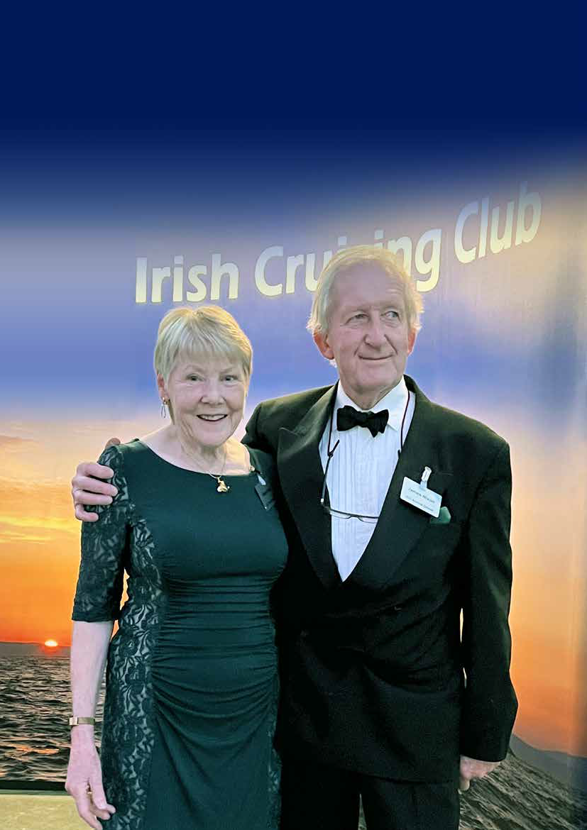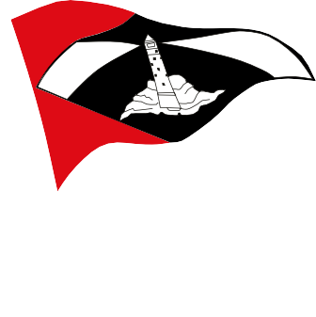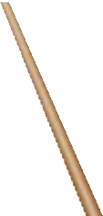

Spring 2023

Page 2 ICC News, Spring 2023
Dear Member,
Spring is in the air, the bees are buzzing, the birds are chirping, and our boats are coming out of their winter resting places in advance of what we are all hoping will be a fantastic sailing season.
Parallel to getting this newsletter out to you, we are also working on updating our website. John Clementson did herculean work creating and maintaining it up to now. This will be the foundation for things to come. The ambition is to provide you with a new look and feel, plus new functionality throughout. The hope is to provide you with a resource you will want to use frequently.
Once again, my thanks goes out to everyone who took the time to contribute to this edition of your newsletter. I hope you enjoy it as much as I did putting it together. As has often been the case, when I started assembling it, I feared I might not have enough to keep you interested. The result is what you have in front of you now.
I wish you fair winds and following seas for the coming year. Alex Blackwell, Editor

Submission guidelines

Editorial Preferences (please):
Please only use standard fonts. Do please use italics for vessel names. Remember to check spelling and grammar thoroughly. Please do not manipulate or retouch the images - send only the high resolution originals.

Text
Articles should be in MS Word or text format only. They may be up to approximately 500 words in length, with a maximum of 1,000. Shorter articles are also very much appreciated.

Images
Images should be sent as separate files - not embedded in an email or Word document. They should be in jpeg format and a minimum of 1 megabyte each. Please do not manipulate, clean up, colour correct, retouch, or crop the images. Please send the original images straight out of the camera. Please also supply captions.

Please send materials to any one of the editors:

North | Maeve Bell | maeve.bell@btopenworld.com
East | Alan Markey | alanjmarkey@gmail.com
South | John McAleer | mcaleerje@gmail.com
West | Conor O’Byrne | conor.obyrne@nuigalway.ie
Spain | Peter Haden | mr.peterhaden@gmail.com
Editor | Alex Blackwell | editor@IrishCruisingClub.com
Larger files may also be sent via Dropbox or WeTransfer.
Alternatively, the materials may be put on a CD or memory stick and mailed to:
Alex Blackwell, Port Aleria, Rosnakilly, Kilmeena, Westport, Co. Mayo, Ireland F28H393

Closing dates for submissions:
Spring Issue: February 28th Autumn Issue: September 15th

ICC News is the newsletter of the Irish Cruising Club
It is published twice a year for private circulation to members of the Irish Cruising Club. This newsletter is copyright
© The Irish Cruising Club. The copyright of the individual articles herein rests with the authors. The views and opinions expressed therein are those of the authors and do not necessarily reflect the policy or position of the ICC. No part of any article may be reproduced in any format or stored in any retrieval system without the written permission of the author.
Front Cover: ICC members Maeve Bell and James Nixon, new inductees in the RYA NI Hall of Fame

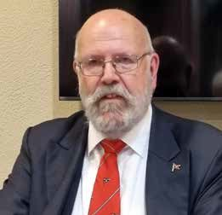

Commodore’s Letter
By David Beattie

All the promise of a new season to come….
The days are lengthening, plans are afoot for a full and exciting season and the annual dinner weekend is just around the corner. What a difference a year makes! Your Club committee has adventurous plans for 2023. But first we had the AGM which this year took place in the Royal St George YC in mid-February, by kind permission.
At the AGM we saw a major changeover in personnel. Derek White stood down as Vice Commodore after almost twenty years of committee and officer involvement. He was succeeded by Julie Chambers as northern Rear Commodore and by Alan Markey as Vice Commodore. Ann Lyons has retired, and Seamus O’Connor is the new Rear Commodore south. Donal Gallagher has taken on the role of Honorary Secretary while Harry Whelehan has stood down from that position and joined the committee. Gráinne Fitzgerald, Bruce Fennell, Des Moran, and Peter Mullan have retired from the committee. In addition to Harry, John Coyne, John McAleer, David Meeke, and Jim O’Meara have joined it. Finally, after a monumental stint that effectively invented the role of webeditor, John Clementson has retired and will be followed in that position by Alex Blackwell. To all our retirees a heartfelt thanks and to all our new blood, good luck. You have hard acts to follow!
At the AGM I made the point that the future of the Club is in the hands of the members. It is firmly dependent on strong candidates being put forward for membership each year by our current members. The committee especially welcomes younger candidates and a good balance of the sexes.
The AGM was followed by our awards ceremony, which was presided over by this year’s adjudicator, Tom Kirby, who brought his usual wit, insight, and charm to the occasion. Congratulations to all the award winners, contributors, and especially to Máire Breathnach our editor for another outstanding edition.
By the time you read this our annual weekend will have taken place in Ballincar, near Rosses Point, Sligo. We have reverted to the traditional two-night programme, and I am delighted to tell you that the hotel and the various events are booked out. The thinking behind this is that if the event is restricted to one night, then many people only attend the dinner itself and miss the opportunity to socialize during the day with other members.
Plans are well afoot for our major cruise this year – the Saoirse Voyage which aims to celebrate and re-create the first leg of our first honorary member Conor O Brien’s spectacular circumnavigation between 1923 and 1925 south of the great capes. The Ilen, designed by him for the Falkland Islands Company in 1926, built in Baltimore, and recovered and restored by Gary MacMahon in recent years, will leave the Royal Irish YC following lunch on 17th June for Madeira. It will be crewed for the trip to Madeira by ICC members and will be joined there by more than 40 yachts, mainly ICC but also including some of our friends in the RCC, OCC and ANC (the Portuguese Cruising Club) on the 3rd of July. I am delighted to report that Alex Delamer, son of our member David and great grandnephew of Conor O Brien will be sailing on the outbound voyage on the Ilen. The 3rd of July will mark the exact centenary of O Brien’s arrival in Madeira at the end of the first leg of his voyage and will be the beginning of a week of celebrations that are being generously supported by the government and authorities of Madeira. All members are invited to join the lunch at RIYC and to mark the departure and an email invitation and booking form will issue in due course. While there is a waiting list of boats wishing to join the cruise to Madeira several members have berths available on their boats and anyone interested should make enquiries to the sub- committee chaired by Rear Commodore Seamus O’Connor if seeking a passage berth out or back from “the Island”.
At roughly the same time a group of ICC boats will sail to the west coast of Scotland, mustering first at Rathlin Island for a joint cruise with the Clyde CC. This adventure will be led jointly by the Vice Commodore and Derek White. Before that the East and Northern regions have a joint muster at Carlingford on the last weekend in May. I hear of plans for a northern rally late in the season (full details will issue shortly by email) and am pleased to report that the usual Encuentro Náutico extravaganza in Galicia has been postponed until late July to facilitate yachts returning from Madeira. Full details are available from Peter Haden and his team.
Early in March Aoife and I travelled to represent the Club at the Royal Cruising Club annual dinner, held this year in Trinity House, London, headquarters of the lighthouse authority for England, Wales and the Channel Islands. As always, we were made most welcome and it gave us an opportunity to open discussions on how we might share

some of the celebrations of our centenary in 1929, which will also be their sesqui-centenary. The two clubs have a long history of working together on such events. A working group has been formed to make preliminary plans for this important event in the history of the Club and we will be reporting to members as plans evolve.
So, all in all, 2023 is looking like a bumper year for our Club, if all our plans come to fruition and the weather gods look kindly upon us. So fair winds and following seas for the year and I look forward to meeting up with many of you during the season.
David Beattie, Commodore

2022 Western Christmas Lunch

by Daria Blackwell
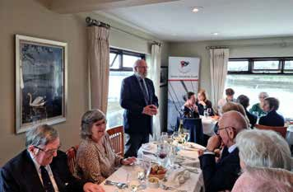
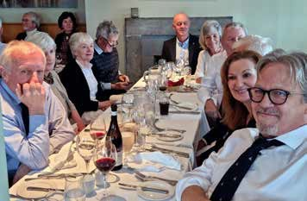

The 2022 Western Christmas Lunch in the Pier Head Restaurant in Kinvara on Saturday November 22nd was

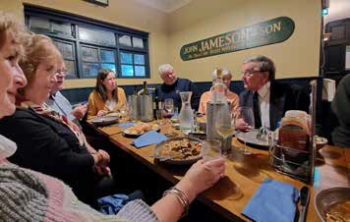
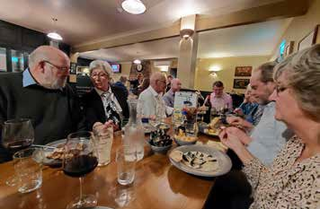
the biggest lunch held in the west in living memory. 65 people attended the event with members coming from
every corner of Ireland. The food was first class, and wine flowed freely.
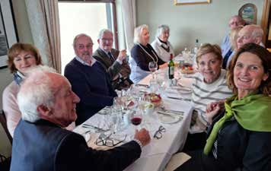
Peter Haden kicked things off with a lovely ‘Grace’. Commodore Beattie and Vice Commodore White separately welcomed members and guests. The afternoon passed far too quickly with animated conversations all around the two rooms we were occupying.
A number of people were staying over so we regrouped that evening at Keogh’s Bar and Restaurant. Mary Whitehead joined us for a while. Then 17 sat down to another delicious meal.
Again, the conversations and stories ranged widely until quite late in the night. A few last greetings over breakfast rounded the weekend off quite superbly.

2023 New Members

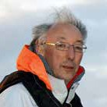
Aedan Coffey, Kilkenny
Aedan has been sailing since about 1967 on boats ranging from Mirror dinghies to keelboats. Since he started cruising in 1981, he has cruised between Concarneau and the Orkney Islands in various types of boats. He and his wife Phyllis currently cruise in an Oceanis 411 called Ar Ais Arís from their base in Baltimore. They are looking forward to exploring more of western Europe.

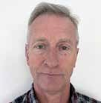
Robert Kilkelly, Westport, Co. Mayo
Bob started sailing at 15 in Mayo Sailing Club’s Laser fleet, campaigning in regional regattas. Later, he competed in the MSC cruiser/racing fleet, WIORA, and many National Class events including Cork Week. He has done several shorthanded deliveries, sailing 1000s nm to and from regattas. Now based in Vannes, Brittany, Bob is enjoying the many challenges cruising the Atlantic, including frequent visits to Scilly Isles and Ile D’Quessant, with Galicia on the Radar for 2023.

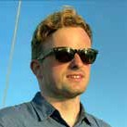
Conor English, Crosshaven, Co. Cork
Conor has been sailing since he was a child, growing up in Crosshaven, Cork Harbour. He learned sailing at Sailcork and the RCYC. In 2013 he completed his ISA Yachtmaster. He has two sailing dinghies: a 1960s Rankin Dinghy and a 1949 Cork T Class clinker d inghy. In 2019 he won overall champion at Cork Dinghy Fest at RCYC. In 2020 he acquired Miss Demena, a boat of which he has had great experience with ICC events, from Flor Long ICC.

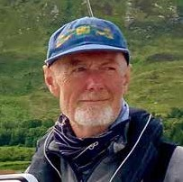
David MacDonald, Carrickfergus, Co. Antrim
David came to yacht sailing in 2015 when a friend asked him to crew. Discovering the joy of cruising, he bought an aluminium cutter with blue-water plans. In 2020 he made a passage from the Galapagos to Tahiti on an Ovni 395 during COVID lockdown. He recently moved to Belfast and is enjoying exploring the area. He is looking forward to an Ireland circumnavigation.


Johnny Ritchie, Groomsport, Co. Down
Johnny is a past Rear Commodore of RUYC. He has sailed competitively for over 55 years from dinghy classes Cadet, GP14, 505, then day yacht racing in Squib & RS Elite, big boat racing for 46 years cumulating in his most recent yacht, Mingulay (Dufour 41 Classic) for past 9 years. He enjoys cruising with his wife, Mandy; from as far north as the Outer Hebrides to as far south as the Isles of Scilly.

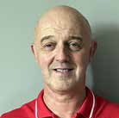
Kenneth Cunnane, Listowen, Co. Kerry
Ken’s earliest experiences on the water were with his Father, Paddy Cunnane, a founding Trustee of Foynes Yacht Club and Trustee of Foynes Harbour. In his late teens he was fortunate enough to sail on Asgard II for 5 trips. His current boat is Mynx, a Swan 46. Each year he makes a point of having the family together for one decent offshore race and a family holiday on Mynx for a two week period.

Ancient predators of the sea bed!
The Naturalist’s
Notebook

by Bob Brown

If there’s one animal that symbolises marine life, it must surely be the starfish. Illustrations of the seaside invariably have a starfish in the scene and children are fascinated by them. Just as often however, when we really encounter these beasts, they are dead, washed up, and usually dried to a pale shadow of their real selves, and usually smelling somewhat. Or worse, flogged off as souvenirs.
Let’s put the record straight! Whilst we floating folk may not instantly encounter starfish on a cruise, there’s a fair chance we’ll find them on our mooring strops, under pontoon structures, and on harbour walls. You can be sure that our very youthful cruisers will find them on rock pool expeditions. They are all over the place, or more appropriately, all under the place, and they are often very colourful.
Starfish are the descendants of a long and very ancient line of animals that include sea urchins, sea cucumbers, feather stars, and brittle stars. Formally, they are called ‘echinoderms’, ie ‘spiny skins’, sea urchins being the spiniest of the lot. If you are interested in antiquity, take a wander along some shores in Co Sligo. You’ll find stones and boulders covered in multitudes of spots, millions of them. These are the fossilised stalks of Crinoids, sea lilies, but not a plant at all, a part of the Echinoderm tribe, and they date back to about 350 million years ago. Sometimes you’ll actually find their tentacles cast in stone.
But let’s concentrate on the starfish. Most have five arms, but the dramatic looking common sun star, may have anything from ten to thirteen arms. For beasts that are supposedly primitive (they aren’t really) these
are complex organs. If one is broken, or bitten off, it is capable of growing a new central body if it
hasn’t been damaged too badly. And the previous body is well able to grow a new arm as well, although it may not be quite the size of the original. Turn the starfish over, and you’ll find intricate rows of tiny transparent sucker-like feet – tube feet. These, by moving in rhythmic pulses along the arm, allow the starfish to creep across the seabed, though of course there’s a cunning co-ordination mechanism that keeps the teams of tube feet under the other arms contributing to the directions rather than trying to pull the wrong way.
However, that’s only the beginning of the story, because the arms and tube feet have another role. Starfish are major predators of the seabed, feeding on carcasses, organic detritus, other slow moving fauna, particularly molluscs, and even other starfish. It’s not a pretty operation. If a starfish encounters a mussel or clam for example, it wraps its arms around the victim, latches on the tube feet with their suckers, and slowly pulls the two shell halves apart. When finally, the exhausted shellfish gives way, the starfish everts its stomach, inserts it into the gape of the victim’s shell, and then digests the animal alive, finally withdrawing its stomach when the job is done.
There is hardly a single marine habitat where the seabed doesn’t have one or more species of starfish, although they are absent from the middle to upper shorelines, not being very good at resisting desiccation when the tide is low.

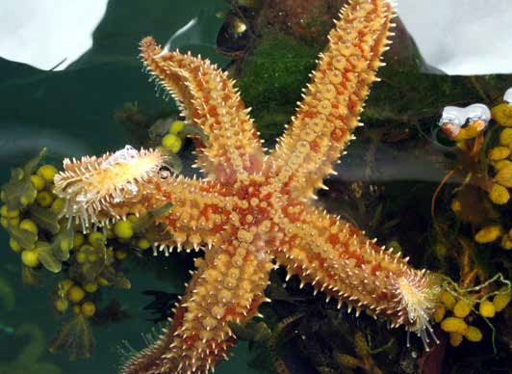
We encounter the most frequent species, the common starfish, yellowish or orange, on reefs, wrecks, mussel beds (of course), and often accompanied by the spiny starfish, with a skin dimpled by spiny protrusions. In the depths, and sometimes along the low water line, we can find a small deep red-purple starfish, with smooth arms, going by the glorious name of bloody Henry. Sandy or stony sea beds have the more primitive and appropriately
Spiny starfish Marthasterias glacialis on a pontoon structure and obligingly showing us its tube feet in Kilmelford, Argyll & Bute, Scotland.
Photo by Linda Brown

named seven armed starfish. They are enthusiastic breeders, each adult capable of producing over two hundred million eggs a year – thank goodness for high mortality in the larval stages! Along the lower levels of the shoreline, under boulder and weed, you may find the cute little cushion star, a sort of dirty green usually, and looking, well, a bit like a tiny cushion, with short dumpy arms.
In more northern parts of Ireland, and Scotland through to sub-arctic areas, we find the northern starfish. Like many northern species, it doesn’t merely spawn eggs and sperms into the sea giving rise to planktonic (drifting) larvae. Instead, the female gives birth to live young in the spring, and with its arms wrapped around the tiny offspring, gives up feeding and cares for them until their first tube feet have developed and they can forage for themselves. This species is currently retreating northwards due to climate change and increasing sea temperatures.
Shifting species distribution with climate change is as much a feature of marine life as it is in the more documented species and habitats on land.

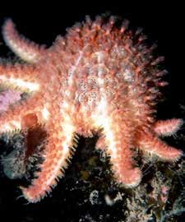
A common sunstar Solaster pappo- sus digesting its victim in Strangford Lough. Photo by Dave Erwin

The European Environment Agency is reporting that sea temperatures in European waters have been rising by about 0.3°C per decade in recent years, and expected to be up to 6°C warmer by the end of the century. Aside from greater warmth, this may affect the way some of the ocean currents operate around Ireland’s coasts.
We should not underestimate the sensitivity of marine life to these changes. Ireland’s marine life lives at a crossroads where subarctic species just manage to coexist with subtropical species at the northern end of their ranges. The situation is made more complex by a series of oceanic fronts around our island. St George’s Channel receives relatively warm water entering the Irish Sea, whilst to the north of Malin Head, extending to Islay, a front separates warmer western waters from cooler to the east. Again, between Co Down and the Isle of Man, a seasonal gyre develops where warmer surface waters are separated from those in cooler depths.
These systems support different species according to their temperature contrasts, and thus profoundly influence their distributions. What the scene will be like by the end of the century, we can only speculate, but it will almost certainly be different. By then our descendants may well be intrigued some very different species of starfish creeping up their moorings!

Western Wanderings

by Conor OByrne*
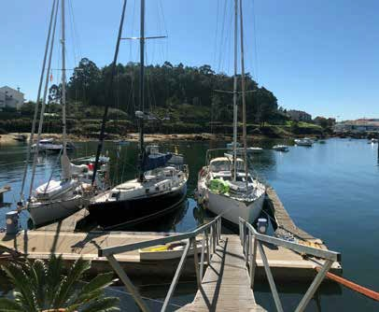
Western members had a quiet winter it seems. The absence of any major winter projects reported to me no doubt reflects the great order that members maintain their vessels in! Phyllis Hayes reports that the propeller on their Westwind 41, Allegra, was heavily encrusted with mussels so that received a generous lick of antifoul during her lift-out in Xufre, Galicia. Phyllis and her husband Michael Casserly will base themselves in A Pobra de Caraminal and do some exploring of the Rias with their teenage son and friends over the season. They are already looking forward to meeting fellow ICC members during the Encuentro Náutico 2023.
Peter Fernie reports that Mystic (his Moody 27) will be cruising around the Rias Baixas again this year. Peter has been busy over the winter with a complete rebuild of an old Mirror sailing dinghy. He is getting it ready for his grand-daughters, both of whom hope to do a sailing course in Galway Bay Sailing Club this summer.

Michael Brogan reports that preparations are already
Page 7
Allegra, Phyllis Hayes and Mick Casserly’s Northwind 41, berthed at the new pontoon in Xufre

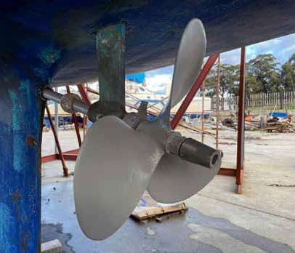
Allegra’s prop paintjob
underway for Cruinniú na mBád, which will be held in Kinvara on the weekend of 11/13 of August this year. This will be the 44th year of this colourful regatta, which is the longest running maritime festival in Ireland. Even during the COVID pandemic, turf was quietly transported by Hooker across Galway Bay to mark the continuity of the centuries old tradition. ICC members are welcome, especially to the BBQ for crews and sponsors, held each year in Parkmore on the Saturday afternoon, while the Hookers wait for the tide to take their cargoes of turf to be landed on Kinvara Quay. Details of weekend events can be seen on Festivals Ireland website.
Galway Port secured €8M investment from the EU to establish the port as a “Hydrogen Valley”. The project, called GH2, is a consortium consisting of seven members - NUI Galway, the Port of Galway, CIÉ Group and Bus Éireann, Aran Islands Ferries, Lasta Mara Teo, Aer Arann Islands, and SSE Renewables. The hope is that this project will position Galway as the home of Ireland’s first Hydrogen Valley, providing green hydrogen for use in transport, industry and within local communities in the greater Galway region. With luck it might also act as the catalyst needed for further improvements of the harbour. Also in Galway Bay, the sailing club at Renville (GBSC) is currently building new facilities for equipment storage and training on the club grounds.
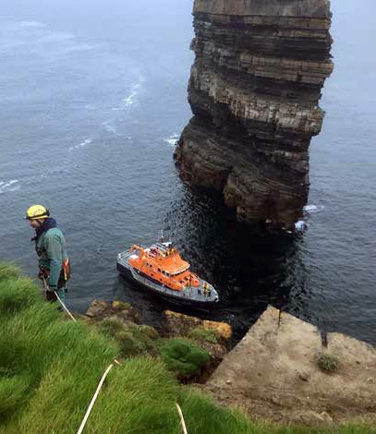Further west in Ros a’ Mhíl (Rossaveel), the harbour master, Captain Martin Mylotte, reports that a facilities building will be opened at the marina sometime between Easter and summer this year. This will have a self-catering facility, showers and laundry. Food and fuel delivery services to the marina are available from the local shop and fuel station. These facilities will no doubt entice a few more visiting yachts into the harbour. Although the town itself doesn’t have much to offer a visitor, the marina is a great place to base your boat for some extended cruising in Western waters.
The dramatic rescue scene at Downpatrick Head

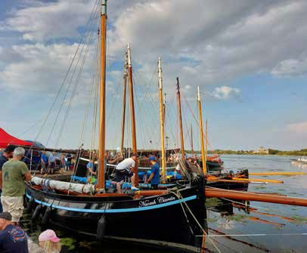
Cruinniú na mBád (gathering of the boats), Kinvara, August 2022

John Sweeney took a hiatus from sailing last summer but will be back on the west coast this coming season. Outside of sailing he is involved in Cave Rescue and was part of the dramatic 23hr rescue of the guy at Downpatrick Head in November. Great result and collaboration with the RNLI and The Coastguard.
* Please note the deliberate omission of the apostrophe in my name. In a very entertaining Zoom lecture in February Jim McAdam told us that the great circumnavigator Conor OBrien (who was, of course, an honorary ICC member) didn’t use the apostrophe in his name. I’m hoping it will help me become a better sailor!

AVIAN FLU UPDATE

It has not gone away!

by Bob Brown
In our last issue I reported on the virulence and devastating impacts of H5N1 virus or avian flu on our seabird populations, notably on gannets, great skuas (bonxies), and wintering geese, but also many other species. I’ve had trouble finding very recent reports or predictions on the internet but an RSPB update from December reports continuing small outbreaks, widespread about the British Isles, and a worrying escalation of infected barnacle geese in Scotland. They also flag up a warning about our breeding seabirds, soon to arrive on our shores.
As I reported, the highly infectious virus thrives in dense seabird colonies, with devastating effects. We’ll soon be out and about around our own coasts and elsewhere, often offshore from colonies, and we can make a major contribution to knowledge and management of the disease.
Please report any sightings that seem to you to indicate a colony, or even individuals are infected, but don’t go near them or worse, handle any sick birds. Signs to look out for include:

Gannets that have all died as a result of avian flu bar one that is ill, Hermaness, Unst, Shetland, July 2022.
Credit- Ashley Cooper (rspbimages.com)
- lethargy,
- unable to lift head or wings,
- various combinations of gaping, coughing, sneezing and diarrhoea,
- bird stumbles around, or swims erratically in circles,
- and, of course, death.
There are other signs too, check out https://www.gov. uk/guidance/avian-influenza-bird-flu#signs-of-bird- flu. Report any sightings to the relevant government administration according to where you are (I think they all have websites for this purpose), or to Birdwatch Ireland or RSPB.

Winter Walks

by Peter Mullan

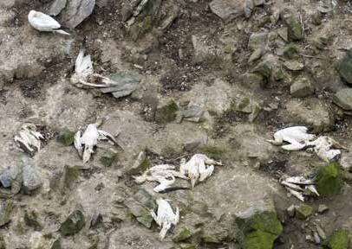
Page 9
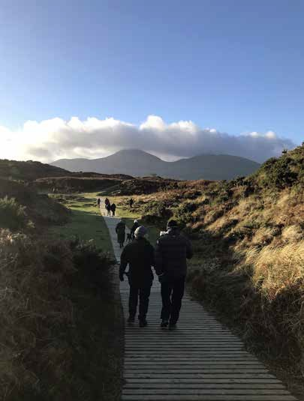
Winter walks are now an important winter activity for members. The east region do serious walks and in the north we do easy ones. This one was from the Dundrum road out of Newcastle to the beach at Murlough. The walk is maintained very well with a boardwalk all the way to the beach. The views are stunning, lots of wildlife, flora, and fauna. The walk along the beach is more challenging on stormy days with sand blowing into eyes but we are hardy people. The dogs love it too, as there is the chance of a swim.
It’s great to chat in the off season. Summer cruises are planned as we check out crew availability and preferences.
Thanks to all the walk organisers who see there is coffee or tea available afterwards.
The weather is an unknown, but we have been very lucky so far.

Looking ahead to the 2023 Annual

by Máire Breathnach
I would like to draw your attention to the updated Notes for Contributors which are set out on the front inside cover of the in 2022 Annual and summarised below.

NOTES FOR CONTRIBUTORS

LOGS
LENGTH: Typically, 1,000 - 4,000 words, major cruises 5,000. Most cruises can be recounted in 2,000 - 4,000 words. Logs should be submitted by email, MS Word or Text format only. Please do not send a pdf. A sketch map and a chronology of ports and anchorages visited should be submitted with your log to facilitate the drawing of the track charts.
SUMMARIES: Particularly for the benefit of the Adjudicator please include dates (start and finish of cruise), area cruised, crew list, overall distance and a description of the boat (if not in the log text).
PHOTOGRAPHS: Send at least 10 high resolution JPEGS minimum 600-800KB. Photographs are best sent by www.wetransfer.com. A list of captions should be included in your log document. It is helpful if the file names of the photos are their captions.

DUNN’S DITTIES
May be 200 - 1,000 words: anecdotal or illustrative of cruise highlights (or lowlights), or a cruise summary.

ARTICLES
Articles of particular merit are welcomed and may be 2,000 - 4,000 words.
EDITORIAL CONVENTIONS: Please read the editorial conventions written on the inside cover of the Annual and follow them as much as possible.

GENERAL
All logs will be entered for awards. Selected photographs will be shortlisted for the Photographic Plate prize. All material, where at all possible, should be submitted in digital format.
I have found that the best logs are written by members who take notes throughout their cruise, write their log at leisure, and then ask a friend, ideally a well-read friend, to critique the work.
My grateful thanks in advance to all the contributors - the cruises you make and the logs you write are hugely important to us all. If you have any queries, please contact me.
The final date for submissions is 20 October 2023.

CLUB AWARDS
For the benefit of new members, I have listed the Club’s
awards below:
- The Faulkner Perpetual Challenge Cup is awarded each year for the log of the best cruise on a sailing yacht owned by a member of the Club, undertaken during the Season by any member, provided that he shall be in command of the yacht. The judge will take into consideration the distance covered, the time taken, the size of the vessel and its crew, the use of auxiliary power, the seamanship displayed, any difficulties encountered and overcome.
- The Strangford Cup, for an alternative best cruise.
- The Fortnight Cup, for the best cruise undertaken in a maximum of 16 days.
- The Round Ireland Navigation Cup, for the best circumnavigation with special emphasis on navigational and pilotage content.
- The Wybrant Cup, for the best cruise in Scottish waters.
- The Fingal Cup, awarded at the adjudicator’s discretion for the log which appealed to him/her most.
- The Rockabill Trophy, for a cruise that includes an exceptional feat of navigation and/or seamanship.
- The Glengarriff Trophy, for the best cruise in Irish waters.
- The Atlantic Trophy, for the best open sea passage with port-to-port distance of at least 1,000 miles.
- The Perry Greer Bowl, for the best first ICC log.
- The Wild Goose Cup, at the adjudicator’s discretion for a log of exceptional literary merit.
- The Marie Trophy, for the best log for a cruise in a yacht up to thirty feet overall.

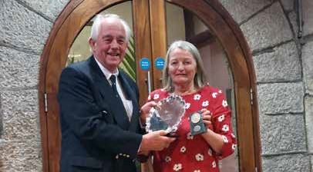
Máire Breathnach presenting the Dunne’s Ditty plate to Norman Kean for his writing contribution in the Annual

Galician Grapevine

by Peter Haden
For the seventh consecutive year a gathering of ICC boats, Encuentro Náutico, EN23, is planned in the Rias Baixas of Galicia. This will take place between 18th and 24th July with help from Peter Fernie, John Bourke, Jim Sammon, and local ICC friend Alejandro Pazo.
The marina at Caramiñal is looking forward to welcoming us and there is a schedule prepared of dinners, a walk in the mountains, an excursion, and some sailing. Weather permitting, it is hoped to finish at the beautiful Islas Ons anchorage and Checho’s famous seafood terrace restaurant. Stanton and Pat Adair are joining Anne and Pat Lyons on Stardancer and will be especially welcome participants.
It is hoped that some yachts returning home from the Saoirse Rally in Madeira will be able to join us. Especially welcome will be members of the OCC and RCC.
Highlights of EN23 include an opening luncheon at Xanxo’s Restaurant on edge of Caramiñal, a walk through pools and waterfalls to the top of Mt. Curota, a short excursion via the mountains to Corrubedo, a cruise in company to Ribeira, a closing Dinner at Ribeira Yacht Club, this is all finished off with a sail to Islas Ons to informally rendezvous at Checho’s Terrace Restaurant.
Whilst normally the weather for sailing in the Rias is perfect, climate change seems to be affecting every place. Strong northerly winds in early July kept many boats firmly in port. More recently in January, on several days the Cangas to Vigo ferry service could not operate.

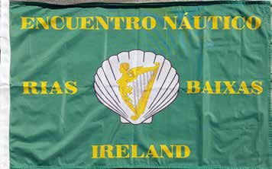
However, during February in Portosin temperatures reached 20 degrees with a flat calm sea on several days.
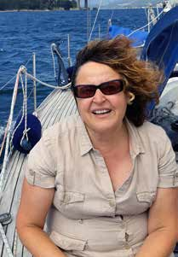Especially welcome for yachts crossing Biscay is the news that an ICC port officer has been appointed for the important ports of A Coruña and Sada. This brings to three the number
Minia Pardo
of port officers in Galicia, all in strategically placed locations.
Minia Pardo who speaks perfect English and sails herself, will already be known to many members as she crewed on Coire Uisge during our rally last year. Her contact details are available in the 2023 LGB.

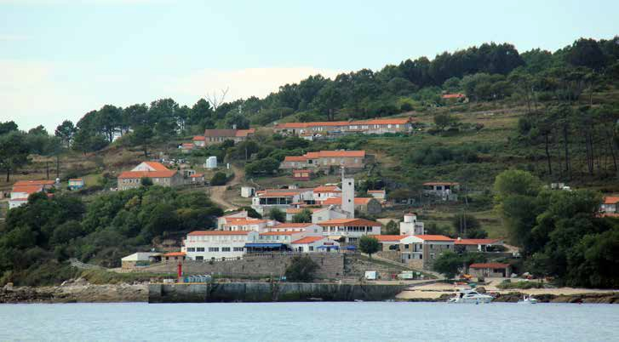
Islas Ons


Across Three Oceans
A Voyage in the Yacht Saoirse

By Conor O Brien

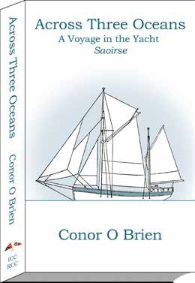
6th Edition
Paperback: 343 pages
ISBN-13: 979-8366211659
Dimensions: 12.7 x 2.18 x 20.32 cm

Available Now
The Pioneering Circumnavigation of the World in a Small Yacht, South of the Great Capes, 1923-1925
It will be of interest to those of us who are fascinated by the history of cruising in small boats, that the book by Conor O Brien about his pioneering circumnavigation of the world in the 42-foot yacht Saoirse that he designed himself and had built in Ireland, has been republished by the Irish Cruising Club together with the Royal Cruising Club.

It is available on Amazon worldwide.
“Mr. 0 Brien’s plain seamanlike account is so modestly written that a casual reader might miss its full significance. But anyone who knows anything of the sea, following the course of the vessel day by day on the chart, will realize the good seamanship, vigilance and endurance required to drive this little bluff-bowed vessel, with her foul uncoppered bottom, at speeds of 150 to 170 miles a day, as well as the weight of wind and sea which must sometimes have been encountered.
... however common long ocean voyages in small yachts may become, Mr O Brien will always be remembered for his voyage across the South Pacific and round the Horn.”
Claud Worth
Introduction to the first edition

This 6th edition of Conor O Brien’s recounting of his epic journey includes the twelfth chapter from the first edition, later omitted. It also includes his logbook extracts that only appeared in the first edition. This is the first digitally produced edition. It is available on Amazon worldwide and from book shops.
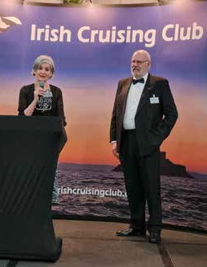
EDWARD CONOR MARSHALL O BRIEN (1880-1952) was an architect,
author, boat builder, and yachtsman. He was best known for his sailing exploits. Born on 3 November 1880, He was the second son of Edward William O’Brien of Cahirmoyle, Co. Limerick, and a grandson of William Smith O’Brien, an Irish nationalist Member of Parliament (MP) and a leader of the Young Ireland movement.
As a ship designer and builder, his notable boats include the Kelpie, the Saoirse and the A. K. Ilen (a Falkland Islands service ship) built in Baltimore, Ireland. In 1914 he used his yacht Kelpie to collect a cargo of arms for the Irish Volunteers from a German tug in the same gun running operation in which Erskine Childers’ yacht, Asgard, took part. Saoirse would have been the first pleasure boat flying the tricolour to enter foreign ports and it was the first yacht to circumnavigate the world by way of the three Great Capes. O Brien, who was also a mountaineer known for climbing barefoot, had set out originally to join a climbing expedition in New Zealand but arrived there too late to take part due to a delay with his sea voyage.

Both the Saoirse and Ilen have now been restored and/or rebuilt and are sailing in Ireland.

Caroline Delamer speaking at the launch of
Across Three Oceans

2023 New Members

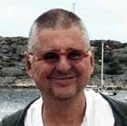
Leszek Wolnik, Sandymount, Co. Dublin
Leszek is an avid cruiser, sailing all of the Norwegian coast clockwise to Lofoten, mostly singlehanded in his Vancouver 32. He has cruised Svalbard leaving from Tromso. He has also sailed much of Sweden and, closer to home, has circumnavigated Ireland and the Faroes. He is presently moving towards the Caribbean, possibly via Gambia and the Cape Verdes, to transit Panama in 2024 with the intention of competing in the 2026 Solo Tasman Race from New Plymouth, NZ.

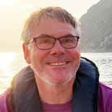
Mark Sweetnam, Goatstown, Co. Dublin
Mark cruises for 4 to 5 summer months annually with his wife Dawn aboard his 1992 Najad 420 Don Carlos. Because of Covid restrictions the last few summers have been restricted to the coasts of Ireland and Scotland. Future plans include cruising the entire coast of Norway and the Baltic, overwintering in Scandinavia for a couple of winters. He also enjoys sailing the sprit-rigged Chameleon nesting tender he built.


Paddy Judge, Howth, Co. Dublin
Paddy began sailing in 1972. He fell in love with it and spent the past 50 years cruising Irish coastal waters, Scotland, England, and France. He bought a 35’ hull in 1979, which he fitted out and still sails 43 years later, generally single handed. Paddy was Commodore of Howth YC for the past five years. This year he plans to sail north up the Scottish Coast to the outer isles. If the winds are unfavourable, he will sail south to the Brittany coast again.

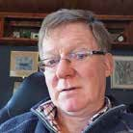
Dr Patrick Hartigan, Doolin, Co. Clare
Pat is a Chartered Engineer. He started sailing in the 1990s, when he purchased a Nauticat 33 in France and brought it home to Kilrush. He has since sailed many European seas and in Arctic waters. He is a regular skipper of the Irish Whale and Dolphin Group’s steel ketch, Celtic Mist. He also owns a 63’ Dutch Barge, which he keeps in Dublin. Pat hopes to spend 3-4 weeks leading Irish Whale and Dolphin Group crews on citizen science expeditions off the south-west coast of Ireland this year.

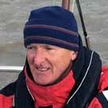
Pat O’Shea, Ennis, Co. Clare
Pat has been sailing for nearly 40 years. He started with a Glenans course which got him into windsurfing. Over the past 35 years, he has part owned 5 yachts before becoming sole owner of his current boat, Amergin, a Malo 36, which he purchased in 2016 and berths in Kilrush. He has cruised round Ireland, south coast of England, the Baltic, Brittany, and Galicia. He competes in “white sails” racing in Kilrush and WIORA.

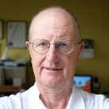
Peter Bowring, Dalkey, Co. Dublin
Peter started sailing in the mid ‘60s aboard his father’s yacht Shindilla (formerly Bob Berridge’s) and completed the ISA’s 3 stage junior sailing. He sailed with Eric Healy aboard the Asgard and latterly the Creidne including a west-east trans-Atlantic in 1976. Later he worked aboard the Asgard 2 as her engineer. In 2020, he bought his own yacht and managed a very successful round Ireland cruise in 2021. This year he hopes to make it to the Scillies and Brittiany.

Iberian Orca Interaction Update

by Daria Blackwell

Mónica González, Bióloga Marina de CEMMA - Coordinator for the Study of Marine Mammals, gave a talk at the Irish Sailing Cruising Conference at the Royal Cork Yacht Club in Crosshaven on the 11th of March 2023. She presented a great deal of information now available on the Orcas that have been interacting with sailboats in the past few years.
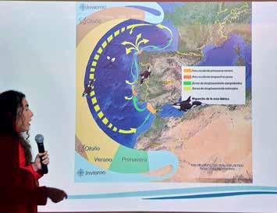
Ms. González explaining the annual migration of the Iberian orcas.
CEMMA and Orca Iberica have identified 15 orcas, of the resident population of 35 remaining animals, that are taking part in the interactions. Monohull sailboats were involved in 80% of reported incidents. It appears that the interactions, particularly with spade and double- spade rudders (72%), are a learned behaviour, being taught by the mothers to their offspring.

They have postulated one of two reasons for this behaviour:
- Young animals have learned that it’s fun to interact with the rudders and have been making a game with ‘particularly attractive’ rudders
- Adults have responded aversively to an injury or other negative moment associated with the presence of the sailboats, such as correlation with lower abundance of tuna, the primary food source for this population of orcas.
The behaviour follows a repeated pattern, wherein the orca circles the boat to look at the rudder. If it really ‘likes’ the rudder, it blows out a strong raft of bubbles. After this, it dives and pushes the rudder to spin the boat. If the boat stops moving, the interaction typically lasts less than 10 minutes. Continuing to move keeps the interest of the animals, which continue to interact and may actually call in their friends to take part. This may result in destruction of the rudder and incapacitation of the boat.
The key protective measure they have identified is that stopping the boat, so it is motionless in the water. This reduces the length and severity of interactions. They have observed that the orcas are attracted to the prop wash of boats and that they often preen in the prop wash with their faces in the stream. Shutting off the engine and all electronics that produce in-water sounds helps reduce the length and severity of interactions. The majority of interactions occurred during the day, so night-time transits, farther offshore, may be more prudent.
Mónica pleaded with the sailing community to help provide as much information about interactions with orcas as possible. A new app is available (GT Orcas in iOS and Android, with optional English) that may make it easier to report interactions and prompts for the types of information that is most valuable, including:
- Photos of the dorsal fin.
- How and when the animals were first spotted?
- How long the interaction lasted?
- How many were involved?
- Details about their boat, including rudder types and bottom paint colour.
- What the mariners did in response to the interaction?
- What was the outcome?
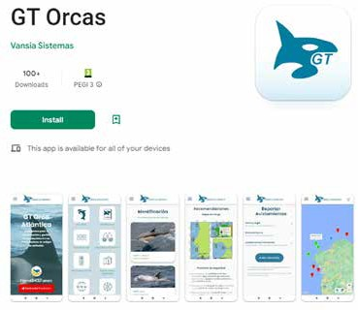
You can also report any interactions to the CA who have established a database of reports. https://www.theca. org.uk/orcas

For more information, visit:
- https://es.oraiberica.org/
- https://www.facebook.com/OrcaIberica/
- https://www.instagram.com/orca_iberica/
- https://twitter.com/Orca_Iberica

Presenting the ICC Decanter

by David Beattie
The ICC decanter was originally presented to the RCC by the Irish Cruising Club in 1989 to be awarded for “a cruise
of exceptional merit”. It is presented at the RCC Annual Dinner.

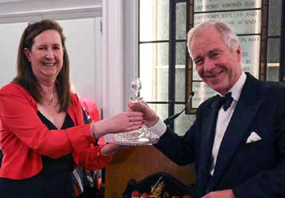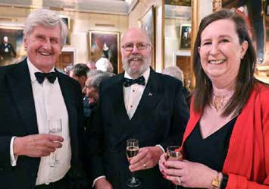

Aoife presenting the ICC Decanter to Donald Begg for “his extended circumnavigation of the UK” at the RCC dinner.
David and Aoife with Nigel Wollen at the RCC annual dinner in Trinity House, London

Returning to Southerly

by Michael Boyd

We returned to Southerly in mid-December after her eight-month lay up in Clarke’s Court boatyard, Grenada. She had been looked after by a local guardian, who ensured that she was dry and safe as well as supervising some painting and varnishing. Southerly’s standing rigging had also been replaced in a measure required by our insurers’ ten-year age limit.
Before Christmas, four Greenwoods (Tim, Vanessa, Annabel and Christina), great cooks and easy company, joined Phyllis and me for a fortnight’s cruise through eight islands in four countries Grenada, St Vincent and the Grenadines, St Lucia, and Martinique, our current resting place. The highlights were Christmas in Bequia, swimming with turtles in Carriacou, enjoying the smart berthing at Glossy Bay, Canouan, the marina and resort of Dermot Desmond and others, and the hitherto un- visited delights of Martinique and the marine facilities of the great harbour in Le Marin.
The Greenwoods were succeeded by delightful Galway guests - Tim and Asta Reddin and Aideen Kilkelly, a repeat visitor from last April.
Some more work is now underway in Martinique (electrics) and the plans are for two further visits, including a passage to Antigua and a possible hurricane season lay-up there, insurance permitting.
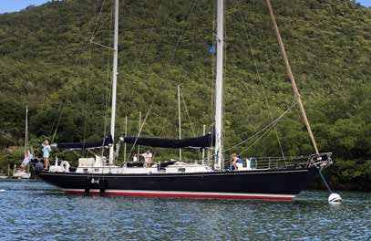
We welcome enquiries from prospective part-owners willing to share the benefits of our beautiful S & S 55’, a youthful 50 years old in 2023 and in fine condition.


Join The ICC Facebook Page!

For current news, information, events, and some lively discussions
Just search for “Irish Cruising Club” on Facebook, click on the link to the group page, and then click on the ”join” link. If you are an ICC member, you will be admitted.

Page 16 ICC News, Spring 2023

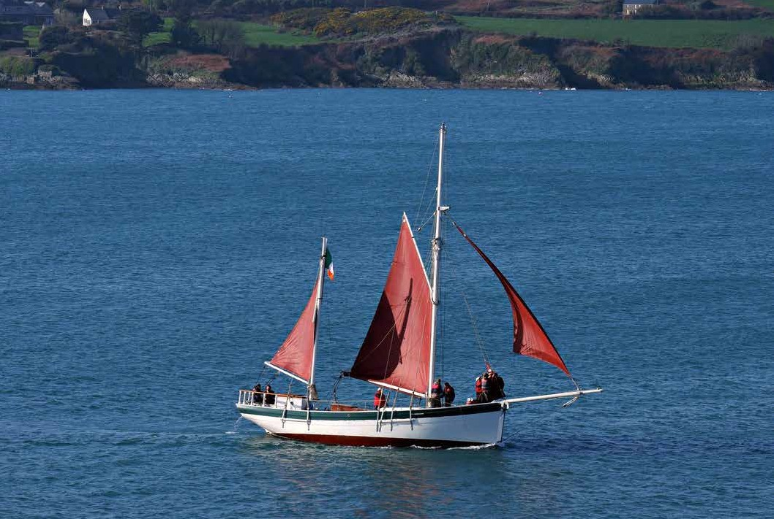Planning for the Conor O Brien Commemorative Rally to Madeira known as the “Saoirse Rally” is well underway.
Saoirse Rally Update
by Séamus O’Connor
Saoirse replica underway
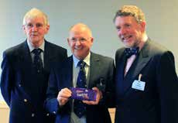
Our Commodore David issued an invitation to our ‘sister’ clubs to join us in the Commemorative Rally. Presently we have received 45 expressions of interest made up as follows:

ICC | 25
ANC | 8 | [Associação Nacional de Cruzeiros – based in Lisbon]
CCC | 2 | [Clyde Cruising Club]
OCC | 6 | [Ocean Cruising Club]
RCC | 3 | [Royal Cruising Club]
Guests | 1 | [Galicia]
Conor O Brien and Saoirse departed Dun Loaghaire on the 20th of June 1923 and
made a very fast passage to Madeira. It was the first port of call on his around the world voyage. Our plan is to arrive to Funchal on 3 July 2023, having first assembled in Porto Santo, the small island to the NE of Madeira.
You probably know that a replica Saoirse is currently nearing completion at Hegarty’s Boat Yard at Oldcourt, Baltimore, commissioned by Fred Kinmonth who has a holiday home in the area. In this recent photo (above) Saoirse’s newly fitted sails are being commissioned.
The classic lines of the boat are a joy to behold! It is unlikely that Saoirse will be ready in time to join the rally, but, perhaps it may make Dun Loaghaire to see off the Ilen.
We are very excited that the Ilen will be taking part in the rally, skippered by James Lyons (ICC) and crewed by ICC members. The departure plans for the Ilen are being developed but it is likely that Ilen will depart Dun Laoghaire on the 17th June. Let’s hope we have a worthy send off!
Our Galician based members lead by Peter Haden have offered to facilitate and help any rally participants as they cruise south via Galicia. Returning yachts have also been invited to participate in Encuentro Náutico 2023 commencing on July 18th and running until July 23rd.
There will be a programme of shore activities in Funchal. The idea is once all boats are securely moored in the ‘Events Basin’ they will remain there for the duration of the programme .

The key dates for the Saoirse Rally remain as previously advised :

30th June to 2nd July | Fleet gathers at Porto Santo Anchorage. Porto Santo is very interesting from a geological perspective so we hope to organise a tour of the main features of the island.
3rd July | Depart Porto Santo at dawn to arrive in Funchal in the afternoon.  Nautical stop to assemble fleet for sail-past before docking in Event Basin  Welcome by CNF and Madeiran Authorities and a band!
4th to 7th July | Programme of activities in and around Funchal.  These will include levadas guided walks, historic Funchal, botanical gardens, toboggan ride in traditional wicker baskets, wine tasting at Blandy’s. Madeira has every type of activity that one could think of so participants will be spoiled for choice!
8th July | Closing Dinner
Yachts will disperse from the 9th June, it is likely that the Ilen, along with many other yachts, will sail NW to the Azores and others SE towards the Canaries. As noted above there is an invitation to participate in EN23 in Galicia.
It promises to be a memorable rally and a fitting commemoration of Conor O Brien’s amazing achievement.

Quest for John Ryan marine paintings

by Pete Hogan
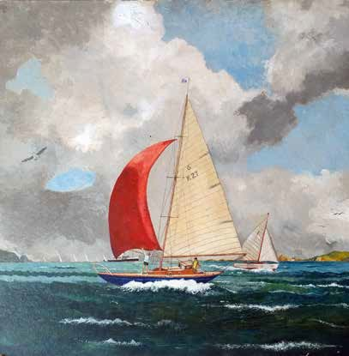
I am attempting to write an appreciation of the paintings and specifically, the marine paintings, of John Ryan (1925 – 1992). I would be interested if any members had any in their possession or knew the whereabouts of any of his output. Ideally it would be great if I could be sent digital images.
John Ryan will be familiar to many as a central figure in the Dublin literary scene of the immediate post-war years. Ryan was the publisher of Envoy Magazine, which first featured stories by Behan and Dunleavy. He owned the Baily Pub, Dublin, was a friend of Patrick Kavanagh and was a Joycean enthusiast. In this regard, he had been instrumental in opening the Joyce Museum in the Sandycove Martello tower, Dublin, and saved the front door of Bloom’s house at 7 Eccles St. when the house was demolished. He is famously credited with establishing Bloomsday as a celebration of Irish literary traditions.
It is less well known that John Ryan was a keen sailor and wrote a wonderful book about sailing and Dun Laoghaire in the 1960s. Called ‘A Wave of the Sea’ he details his adventures in a converted 6 Metre called

Southern Cross. He cruised extensively in the Irish sea and on the west coast, I think. See illustration.
I would be grateful if anyone out there could send me details of his paintings that they might have or know the location of. There is a very fine example in the National Yacht Club where he was possibly a member. The OPW is supposed to have one, which I am attempting to track down. He exhibited over a long career in the RHA and other exhibitions, including ROSC. He contributed many
items to the radio program Sunday Miscellany often on marine themes. He seems to have taken a big interest in the fate of the Spanish Armada and painted pictures of their imagined wrecks on the coast of Ireland. He also seems to have painted botanical subjects, somewhat an odd choice for a friend of Brendan Behan and JP Dunleavy.
Pete Hogan: email pstjhogan@gmail.com or telephone 353 87 930 9559

2023 INFOMAR Survey Plan

by Alex Blackwell
During the current year of the second phase of INFOMAR (2016-2026), operations are planned to take place within the bays, harbours, and offshore areas in the Celtic Sea, Atlantic Ocean, western coastal areas, and Irish Sea areas between March 2023 and November 2023, subject to weather and operational constraints.
Besides the navigatiional hazards this will pose, what is of importance for us is that Aeodon Coffey (new member) has found a way to translate this information into a usable format. This is now finding its way into the next edition of our Sailing Directions!
The INFOMAR Programme (Integrated Mapping for the Sustainable Development of Ireland’s Marine Resource) is a jointly managed seabed mapping initiative between Geological Survey Ireland (GSI) and the Marine Institute, funded by the Department of the Environment, Climate and Communications Covering some 125,000 square kilometres of underwater territory, INFOMAR will produce integrated mapping products covering the physical, chemical, and biological features of the seabed. Expanding upon its operational predecessor, the Irish National Seabed Survey, it has a focus on three sub-programme areas.

Survey Areas
- In the Atlantic Ocean, west of counties Kerry, Clare, Galway, and Mayo.
  - 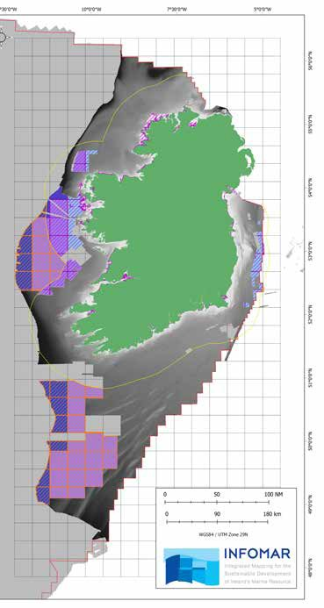In the Celtic Sea, southwest of Ireland.
Map Source: INFOMAR
  - In the the Irish Sea adjacent to the Ireland/UK border from east of County Dublin to east of County Wexford and in coastal areas of County Dublin.
In addition, inshore survey operations will potentially take place anywhere along the coast between NW County Mayo and Malin Head, County Donegal.

Additional Information
INFOMAR Charts and information on a bay basis can be found on the website http://www.infomar.ie. Images, Bathymetry, Backscatter, Shaded Relief, Classification .pdfs are available.
INFOMAR offshore & Geological Survey Ireland onshore digital data can be downloaded via https://jetstream.gsi.ie/ iwdds/index.html.

Member boat for sale

Otter a 1989 Channel Islands 22
Twin Volvo Turbo 43 BHP engines approx. 1500 hours.Davits, Rubber Dinghy, Full cockpit tent, Grounding Legs, full set Electronics, Heads, 2 burner gas cooker, 2 V Berths, Life raft, Lying Crosshaven.
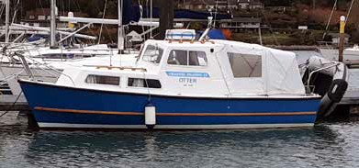
Contact: Dan Cross +353-86-259-8770

ICC News, Spring 2023

Epistle from the East

by Alan Markey
Autumn activities resumed with our regional lunch, held in the Royal St George in October. These lunches are not only a great opportunity to meet other members, but also to introduce potential new members and familiarise them with the activities of the Club. We are delighted that two of the guests who attended this lunch were elected to the Club in January.
On Saturday November 19th, Tony Linehan organised a walk through Cruagh Wood via the boardwalk, onto Cruagh Mountain, and a circuit of Massey’s Wood. While in the woods, John Crebbin provided the walkers with the intriguing history of the Massey Family and Killakee House. This was an interesting walk of 12.5k and 16 walkers attended. We were fortunate to have excellent weather on the day and were enjoying a hot bowl of soup in a local hostelry as the rain started. This was the third walk the East Region organised in 2022 and we will continue to include walks in future event calendars.
The Christmas lunch was held in Howth Yacht Club on December 9th with 110 members and guests in attendance. This was the largest turnout for many years. We were delighted that members from other regions braved the icy conditions and were able to attend.
December 9th was almost sixty years to the day since Winkie Nixon was elected to the club. After lunch, Winkie, in his inimitable style, entertained the group with stories of his many cruises, throughout his sixty years of membership of the ICC.
Now that Spring has officially arrived, we can look
forward to the following events:
- The East Region Spring Lunch which will be held on Friday April 21st in the National Yacht Club. Members from other regions are most welcome to attend.
- On the weekend of May 24th – 26th a joint Eastern and Northern Region rally will take place in Carlingford. Final plans and preparations are being made and booking details will be circulated in the coming weeks.

- 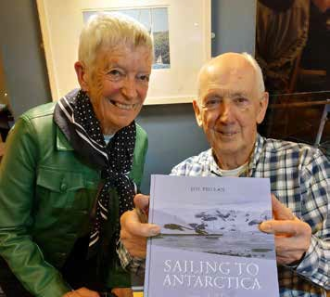ICC cruise in company with the Clyde Cruising Club’s 2023 Distillery Cruise:
Trish and Joe Phelan
  - July 1st Muster at Rathlin Island hosted by ICC.
  - July 2nd Rendezvous at Port Ellen Marina, Islay.
  - July 3rd Visit Ardbeg Distillery.
  - July 4th Rendezvous at Craighouse Bay, Jura. CCC Party & Dinner Village Hall Craighouse.
  - July 6th Rendezvous at Oban Transit Marin and visit Oban Distillery.
  - July 8th Rendezvous Tobermory Marina, visit Tobermory Distillery, and then Pontoon Party at Tobermory Marina.
  - July 10th Rendezvous Loch Harport, Isle of Skye and visit to Talisker Distillery.
So far we have expressions of interest from 24 members who would like to attend some or all of the 10 day rally. Further details will be circulated in the coming weeks.
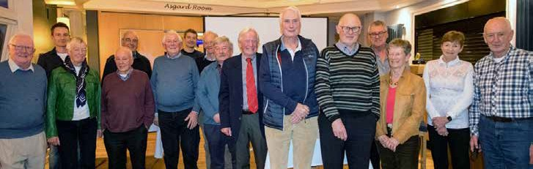Finally, congratulations to Joe Phelan, who launched his book Sailing to Antarctica, a Memoir recently in Howth Yacht Club. The launch was a great event which was attended by Joe’s family and wide circle of friends, including of course, the crew from Peter and Beverly Killen’s Pure Magic. The book covers Joe’s extraordinary sailing career from a self-taught beginner in an IDRA 14 through to some of the remarkable voyages afloat to places many of us only dream about sailing to. The book is beautifully illustrated throughout, and is a great read.
The Crew at the book launch
Photo courtesy of Leo ‘George’ Devill Photography

Page 19

Northern Notes

by Maeve Bell
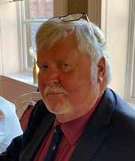
There was a changing of the guard for our region at the AGM in February. Derek White finished his term as Vice Commodore and retired from the committee. Bravo Derek! We will remember with gratitude his energy in organising events for us which ranged from weekend rallies to Annual

single one of us whether through the Little Green Book, the emails we receive, or Facebook and the website.
I am sure we all want to applaud Andy McCarter along with his wife Paddy for his achievement in sailing Gwili 3, their Starlight 35, from the Canaries back to Lough Swilly last summer. This was a major open water passage with zero handy ports of refuge a matter of a couple of hours away. Most of the time they were just two up and, without giving away any secrets, they are both in their seventies. They are very deserving winners

Dinner weekends, and we will long remain deeply
Derek White
of our regional award, the Wright Salver, and carried off
the Fingal Cup as well.

impressed by his sailing exploits especially when faced by adversity, such as last summer when a combination of experience and possibly sheer bloody mindedness got him and Viv round Malin Head and Bloody Foreland in order to represent the North at The West’s Awake. Many thanks to both of you for your service.
We offer a warm welcome to Julie Chambers who has taken over as Rear Commodore North. Along with her husband Graham, Julie sails Big Wig out of Killyleagh Yacht Club on Strangford Lough and is renowned for her organisational qualities which achieve that rare blend of being both meticulous and good humoured. Peter Mullan has stood down from the committee but has kindly agreed to continue as Membership Secretary, while new to the committee since February’s AGM are David Meeke from Belfast Lough and Paul McSorley from Lough Swilly. Des Brown and I will continue to serve. We look forward to a great season.

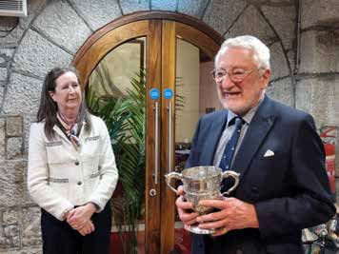
John Clementson receiving the J B Kearny Cup from Aoife Beattie
Each year the Club makes an award for an outstanding contribution to sailing, the J B Kearney Cup, and we were all delighted to see John Clementson honoured for his significant cruising achievements and his years of service to the Club. John’s work has touched every
Following the lead of Leinster, we laced up our walking boots this winter and thoroughly enjoyed four outings. Our game plan was an hour to an hour and a half’s walk with an agreeable coffee destination at the end. We started with a circular route on the Lagan towpath on the outskirts of Belfast, had a blustery outing between Christmas and New Year at Murlough on the County

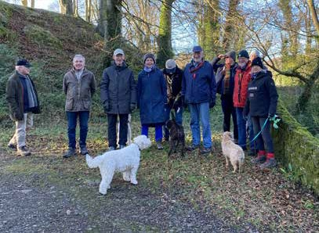
Down coast organised by Julie and Graham Chambers who also brought a trailer-load of seasonal goodies to be scoffed afterwards, enjoyed the rolling drumlins of the Ards peninsula at Mount Stewart estate lead by John Clementson, and finished with a bracing walk organised by Tony and Rosemary Irwin along the north shore of Belfast Lough out to Black Head lighthouse; this time we finished with refreshments in Whitehead.
In addition to all this athleticism, we fitted in some well attended and enjoyable lunches. The first was in central Belfast at the Reform Club through the good offices of Oliver Lynas, the second was our traditional Christmas lunch in the ever-hospitable surroundings of the Royal Ulster Yacht Club with our Commodore David and his wife Aoife in attendance, and the final one, organised by Des and Mo Brown, was a splendid all-day affair which

ICC News, Autumn 2018 Page 21
involved taking the train from central Belfast to Derry and navigating our way 100 metres across the road to Browns restaurant.
Enough of what has occupied us over the winter, the sailing season is almost here. The big events this year are the rally to Madeira to mark the centenary of Conor O Brien’s circumnavigation and the rally to Scotland being organised jointly with the Clyde Cruising Club. Realistically there will be more members heading up the North Channel to the distilleries than south to Madeira although Ed Wheeler in his exceptionally well-travelled Contessa 35, Witchcraft of Howth, may make the passage. Others who may join Ed are Tony Irwin in Pride of Erin and one of our new members whom we welcomed into membership earlier this year, David MacDonald, in Leda. The joint rally with the CCC starts with a party in Rathlin Island on 1st July and, as I write, Derek White has had 22 expressions of interest. These include Scottish stalwarts Ralph McCutcheon in Reziki, Frank and Muriel Smyth in Wild Otter, Bob Brown in Seranade, and Peter Bullick who will be joined by Rosemary Stevenson in Kittiwake.
Fair winds to all concerned.

The Legend of St Molaise of Devenish

by Alan Leonard

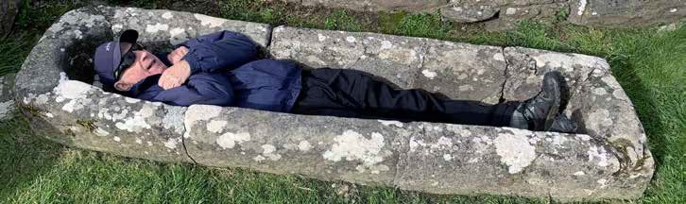

Members who attended the Lough Erne Rally and visited Devenish Island may have read of the Legend of St Molaise, relating to the stone “coffin” present in the chapel. Apparently, if someone who was suffering from an ailment got into the coffin and rotated three times, they would be cured of their affliction.
My son Colin and I decided to put this to the test. It was immediately obvious that his broad shoulders simply would not fit within it. Being of more slender build, I was optimistic, only to find that my shoulders just fitted and my upper arms were pinned by my side There was no room to get an arm past my pelvis to get it underneath me, to allow me to turn over, let alone rotate three times!
Were people much smaller in the mid 6th century? What
little evidence there is seems to suggest otherwise.
There was no room to get an arm past my pelvis, so I could not rotate.
Height (and presumably other proportions in proportion) seems to have declined from medieval times to the 17th and 18th centuries and then increased steadily to the present day.
Was the carved stone trough a sarcophagus at all? Perhaps not. The absence of a lid seems to leave the question open, as there would likely have been carving on the lid, concerning the occupant. If it was indeed St Molaise’ coffin, he must have been of slender build.
In any case, perhaps it would be wise to seek more conventional therapy, rather than this extreme form of alternative medicine!
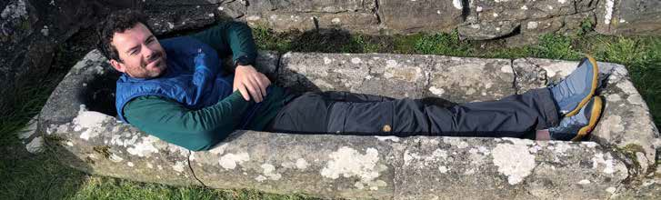
Colin’s shoulders simply would not fit....

Anchoring in ecologically sensitive areas

by Alex Blackwell

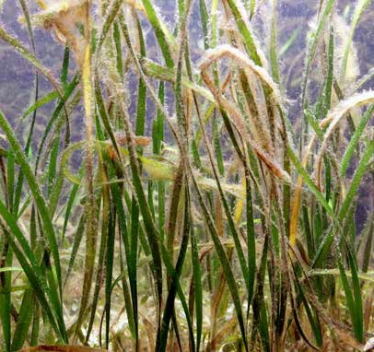
Halodule wrightii, © Hans Hillewaert, used with permission
There is nothing we enjoy more than swinging peacefully at anchor. This is particularly true after a long passage. I am sure we share this passion with most in the ICC. However, we do always check the chart for local restrictions and obstructions, and whenever possible look over the side to see what is actually ‘down there’. There have been times when the bottom turned out to be shingle or shale where no anchor would hold. At other times, we spotted coral heads or seagrass beds, neither of which we would ever wish to disturb.
The latter fall into the category of ecologically sensitive areas, places where anchoring would cause damage to the ecosystem. In fact, anchoring in coral, seagrass (eel grass, Zostera, Posidonia, etc.), maerl (corallina), and other sensitive areas is illegal in many jurisdictions.
Coral is a living creature and is easily damaged by an anchor or chain, this includes breakage, fragmentation, and direct injury to the reef ecosystem. Since some species of coral grow only 1 centimetre per year, it can take many years to recover from an anchoring incident.
Maerl beds provide a complex habitat for a wide range of marine animals with a variety of niches that support high associated invertebrate and algal biodiversity. Maerl beds act as nursery areas for the juvenile stages of commercial species such as juvenile cod, saithe, pollack, and juvenile scallops. Maerl beds offer physical refuge and protection from predation as well as productive feeding grounds. They are easily damaged by anchoring, dredging, and towed fishing gear.
Maerl and seagrass are both plants and are vital to the survival of many precious aquatic inhabitants.
Seagrass beds, previousely discussed in the Autumn 2021 issue, are diverse and productive ecosystems and can harbour hundreds of associated species from all phyla. In addition, seagrass is an important component in our fight against climate change, as it sequesters up to 35 times the atmospheric carbon as an equivalent area of rain forest. By far the most common threat to seagrass is human activity. Activities such as coastal land development, motorboating, anchoring, and fishing practices like trawling or dredging either physically destroy seagrass beds or increase turbidity in the water, causing seagrass die-off.
Our goal, as responsible cruisers, is to help preserve and protect such important resources for their continuity, biodiversity, and the enjoyment of those to follow.
Anchoring in proximity to such areas is, of course, permissible. However, this only applies when using a modern anchor which will not drag. If your anchor has ever dragged, and that has happened to most of us, then the options are to get a better anchor or to anchor far away from a sensitive area. Of course, another option is to pick up a mooring or go into a marina.
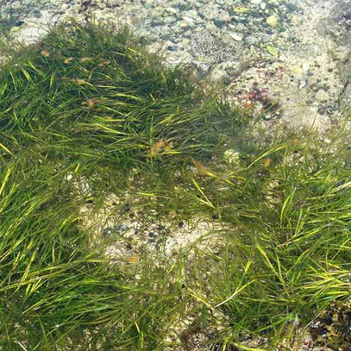
Now, as I said, we love swinging at anchor. Then again, when prudent or if we are i an area where our anchor might cause damage, we do pick up a mooring.

Zostera spp, commonly found in Ireland

The 2022 ICC Communications Survey

by Maeve Bell

Last year your committee was thinking about how best to provide information and decided to carry out a survey. A copy of the survey was included in the autumn Newsletter and sent out by email at the same time.
There were 358 replies by the end of November. A further dozen or more replies arrived later, but the answers did not deviate from the general pattern of responses. The evidence shows there are no outstanding differences between the members who replied and those who didn’t.
First of all, very many thanks to all of you who replied and a special thank you to everyone who sent me nice messages. The headline news is good. We read and are enthusiastic about the Annual, the Newsletter, the Yearbook, and the emails we receive. On the whole, we like getting the first three in print. A minority of us use the website or the Facebook page.
Website. Seven out of 10 respondents rarely or never looked at the website.
Facebook. 47% had no Facebook account. Currently 211 members are part of the Club’s private group which is 39% of the membership.
The Annual. It will not be a surprise that the Annual is popular. More than half (56%) read it cover to cover.
The Yearbook (LGB). This was also universally popular. The majority, 63%, prefer to receive it in print, but almost one quarter (23%) would like to have it both in print and electronically.
The Newsletter. Nine out of ten read all or most of the articles. The majority (63%) want to receive a printed copy in the post. However, rather like the Yearbook, there is a willingness to consider change.
Those who preferred an electronic option gave a variety of reasons for their choice. The three main reasons were that 1) it would cut costs, or 2) that it would be more accessible when they were travelling, or 3) that it was more environmentally friendly/they wanted to reduce paper.

Conclusions
The ICC Annual

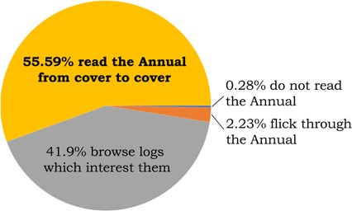

The ‘Little Green Book’
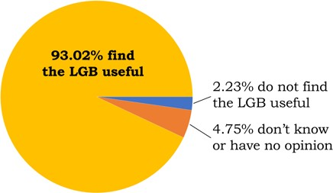
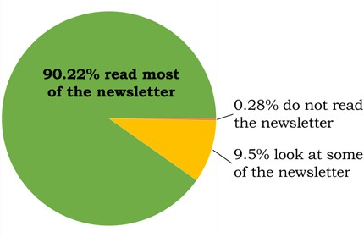
The ICC News

Clearly the majority of us are very happy with what we are currently receiving and wish to see it continue but at the same time there is a move towards electronic formats. Your committee has studied the survey results and is looking both to retain the quality of what we have while at the same time innovate and provide more choice. Watch out for developments!

Southern Soundings

by John McAleer

ICC Southern Members Welcome New Rear Commodore South,
Séamus O’Connor
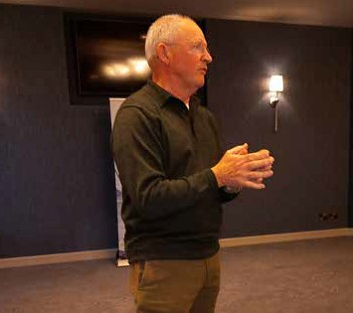
Southern members welcomed Séamus O’Connor as new Rear Commodore South at the monthly lunch held in Carrigaline on Wednesday 1st March. Séamus firstly thanked outgoing Rear Commodore Ann Lyons, on everyone’s behalf, for the wonderful work which she did over the last 3 years, in what were extraordinary difficult circumstances due to the pandemic. Séamus noted that ever cheerful and knowledgeable, Ann steered a safe course and ensured that what was possible and permitted by law was achieved during her term of office.
Séamus, who was elected as Rear-Commodore for the South at the AGM on February 17th. has previously served 5 years on the ICC Committee.
On his sailing background, Séamus purchased the sailing sloop Tapdancer, an ETAP 35i in Southampton in September 1998 and together with the late Captain Barry Dickenson (RFA) completed the delivery voyage to Bantry Bay. He established a mooring in Glengarriff, which has been his homeport since then. He joined the Bantry Bay Sailing Club 1998 and continues as a member, having served in various committee roles.
In Tapdancer, Séamus and his family have explored the Irish coast and cruised to the UK and the northwest coast of France, especially Brittany. He has another boat Slí Eile, a Hallberg Rassy 42, which he sails out of Lagos in the Algarve. Slí Eile has cruised to the Azores, Madeira, Canary Islands, Galicia, and the Western Mediterranean. Typically, Slí Eile is ‘afloat’ from mid- September to mid-June and ashore for the hot summer months!

Jill and Dan Cross
Members will be very pleased to hear that popular ICC South couple Jill and Dan Cross, are back on the water with an exciting new purchase and are busy making Galician plans for this season.
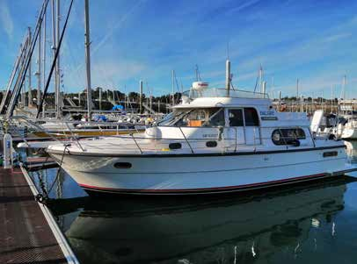Jill writes: “Having sold Yoshi in May 2020, we waited some time to find another craft after a lot of searching not helped by Covid. In October last year, we came across a Nimbus 37 in St. Quai Portrieux in Brittany and
Encore in her berth at RCYC

soon she was ours. We are looking forward to being back with Encore of Cork in Galicia mid to late May after 4 years.”

Bantry Bay Cruise, August 2023
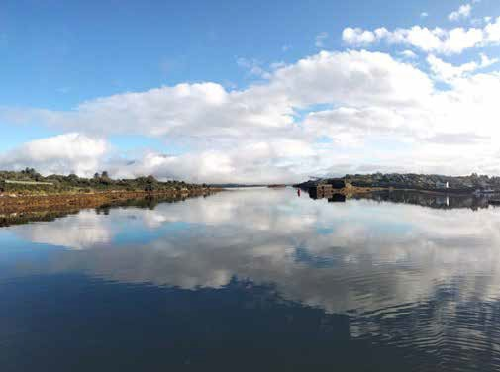Bantry Bay is surely among the most scenic cruising grounds in the country. A Bantry Bay event is now becoming an annual feature of the ICC programme and we are planning to build on that growing tradition with a cruising event taking place during the first week of August, 2023.
The entrance to Lawrence Cove

Tuesday August 1
The Cruise will kick off with a barbecue at Lawrence Cove Marina at 1830. Rachel and Patrick Harrington will look after all members’ berthing and shore-side needs. Patrick will also provide the barbecuing facilities. Please bring your own food and any beverages. http:// www.lawrencecovemarina.ie/about/index.html

Wednesday August 2
At 1100 we will set off on a sail-in-company up Bantry Bay to Bantry Marina and/or the Whiddy Island Pontoon. Members are free to enjoy the afternoon. It might be a nice idea to meet up at Bantry House for an Afternoon Tea, around 1600. https://www.bantryhouse.com

Thursday August 3
The merry making continues, when at 1100, the annual ICC Whiddy Island Chase will commence. Peter and Beverly Killen, on Pure Magic Too have kindly agreed to provide the line facilities.
That evening everyone is invited to assemble for drinks at the Bank House, Whiddy Island at 1700, either using
the pontoon facility, or else travelling on the Whiddy passenger ferry, on which Tim O’Leary has kindly offered to do a special run for members. Dinner will be held at the Bank House at 1900. Kathleen and Tim will no doubt provide us with an excellent meal, using only the best of local produce.
Tim and Kathleen recently renovated the Old School House on Whiddy island, where they provide excellent family accommodation for guests. Rooms of various sizes are available. This facility might be of interest for any members thinking of inviting some additional family or friends. Early booking is advisable. https://whiddy.ie/ school-house/

Friday August 4
We will have an early high water at Bantry and plan to make best use of the ebb tide to take the fleet back to Adrigole Harbour, in time for a lunchtime and afternoon raft-up. Swimming will be a definite possibility. There is also the possibility for Friday evening of having dinner at the Lookout Restaurant on Bere Island, but we are still unsure if the restaurant will be open.

Life under and over the waves

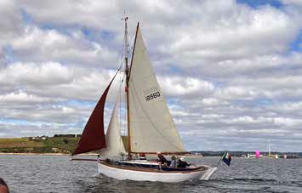by Stephen Hyde
Cruachan looking good
On Monday 27th February a funeral Mass was held in Passage West, Cork for Billy Grainger, a man who got every last drop of excitement out of life.
In 2007 I bought Grainger’s Oyster 56 and in June 2009 we set off from Crosshaven for a trip around the world. The boat was called A Lady and she lived up to her name in every respect. This was a fascinating trip that took 3 years sailing with the World Arc and 27 other boats. We also met Fergus & Vera Quinlan who were also doing the same trip on their own. Fergus & I qualified as architects together in Bolton Street back in the year dot.
- We sailed a total of 110,000 nautical miles, 15,000 miles with just Aileen & me on board
- We motored approximately 5,000 nautical miles – mostly around the equator.
- Our desalination plant could produce 200 gallons of water per hour, so swimming & showers were a frequent
part of life on board, along with cooking, fishing, and keeping in touch with the other boats.
We changed crew from time to time. This included: John O Connor, Mark Newenham, Dermot Lovett, Pat & Ann Lyons, Donal Mc Clement, and Kevin Dwyer; just to mention but a few. Of course, there were times of drama: Donal crashed his moped in the Cook Islands and spent a long time in the intensive care dept of the local hospital. The good news was that Rory Quirk from West Cork had married into the Island and they looked after Donal until he recovered from his ordeal and he re-joined the boat later in Tonga. I gave lots of talks about the trip to yacht clubs, rotary clubs, golf clubs, and schools – always finishing with this comment: Give me the southwest coast of Ireland and Scotland any day of the week for cruising. We were fascinated with pirates. We came close to them on a few occasions. However, a story all about pirates and piracy will be for another day.
So this year we will take the old girl, Cruachan, a 126 year old Loch Fyne Skiff, up to Scotland again. There we will join the cruise in company between ICC & CCC of the Inner Hebrides. This is basically a tour of distilleries and as my father and my uncle worked for Cork Distilleries, this should be very interesting trip for me.

Information and Insight

by Harry Whelehan

Now that I have handed over the joy of being Honorary Secretary of the I.C.C. to Donal Gallagher, I would like to share something with you all.
Over the last three years, I have become acutely aware of the extent to which the role of webmaster is fundamental to the Club, its communications, and its administration. It took me by surprise to discover the extent to which the smooth running of the Club places huge demands on his time, vigilance, patience, and skill.
I do not at all wish to understate the roles of the Flag Officers, the other Officers, the Committee, or the many other members of the Club who work hard in order to make the Club and its events run smoothly. What they do is mostly visible and seen ‘above deck’ and is fully appreciated by the members.
I suspect the same may not be true of the webmaster, because most of what he does is ‘below deck/ backstage’. His activities are as invisible as the oxygen which we breathe, but every bit as essential to the Club, as the air we breathe is to our bodies.
Alas, John Clementson has finally retired from the role of Webmaster after nearly 20 years. I feel that you should understand the contribution which he has made to the Club, its development, and the close communication which we enjoy within the Club.
Back in 2002, Gary MacMahon, then Rear Commodore, created the first club website. It was at that stage a basic, primitive affair, with limited flexibility. Most of our members, I suspect, like me would then, and even now, have been well ‘behind the curve’, in being interested in or understanding the ‘mechanics’ of IT or Information Technology!
John foresaw the necessity: if the Club was to function efficiently in the 21st Century, it had to avail of IT. John consequently signed himself up for two online courses with an American university. There he learned enough to get started. Then with the permission of the committee, he took over the project from Gary. With the help of one Steve Golemboski-Byrne and a small budget, he set up our present website using WordPress.
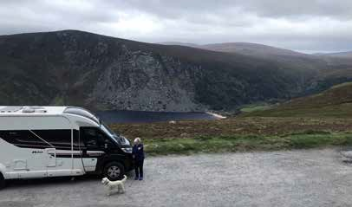This website included the present database, which he later linked to Mail Chimp. The database produces a
John and Ann’s landyacht Faustina 3

csv file from which the LGB is created. It also supplies the addresses for the distribution of the Annual. Amost all communications, whether from Flag Officers, Hon. Secretary, Hon. Treasurer, Committee, or Club event organizers, which you receive, are circulated by the webmaster via Mail Chimp.
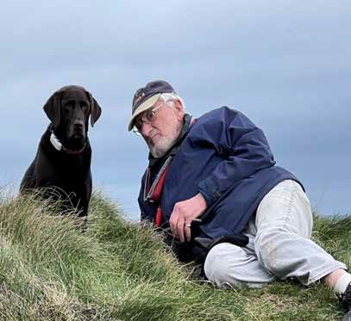About 14 years ago, John decided that the website would be a good vehicle to provide members with records. He arranged to have all of the Annuals scanned and posted on the website, later to be joined by the newsletters. The website is now a very comprehensive club archive.
John relaxing for a change
At his final meeting of the Committee in October last,
John bowed out with the gracious words:
“The time has come to hand over the website, and related matters, not before time you might well say! Things will inevitably change, and quite rightly, change. I hope that the website, under its new direction, can be made more relevant to our members’ needs, whilst remaining a source for the valuable records that reside there. I really look forward to seeing how it all develops and progresses. I will of course be on hand to anyone who takes on any of my various roles”.
John also instigated a Facebook page to encourage and enable members to meet on-line and share experiences. Sadly, to date only about 50% of members have joined. To me this seems a great underutilization of a major club resource. I do wonder if members are unaware of

the existence and accessibility of this amazing resource, or if some feel unable to log in due to a latent IT phobia?
Below I summarise the content of the website for those who have not, or do not regularly visit it.
In addition to all of the above, John has been drawing the charts to illustrate the Logs published in the Club Annual. He also edits and produces the Little Green Book,
You will recall that during the Covid lockdown, John organized regular very interesting webinars to keep us entertained, informed, involved and in touch with each other. He also created groups on the margins of the webinars so that we could gossip and have a drink together in ‘chat rooms’! This medium, the webinar, was recently used to assist members who are planning to take part in the Club Saoirse Rally to Madeira this summer, with talks on weather systems in the area, route planning, and formalities to be contended with on arrival etc.
Without the assistance, and warm friendship which I enjoyed while serving as Hon Secretary. I would not have been able to survive in the role. It was only whilst doing the job that I realized the massive commitment, dedication, expertise, and patience that John brought to the Club and its affairs year in and year out for so long.
This is not intended to be a tribute to John, but an attempt to convey some hard information for members on the ‘below deck’ work of the webmaster, and an encouragement to members to use and appreciate the resource which he has created for us all, and which is part of his legacy to the Club.
Alex Blackwell is assuming the role of Webmaster. I wish him well in the role as he modernises our IT system to be even more useful, and to make our website even more accessible to our members, so that those who have been reluctant to access it may find it easier to use.
A summary of what you will find on our website:
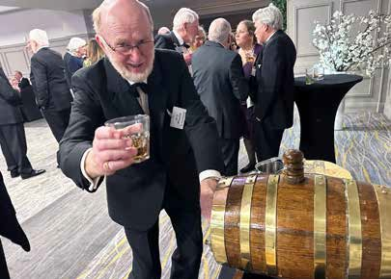
- An events page listing upcoming events
- Member diretory and information
- Club business
- Lists of recipients of Club awards
- All Club Annuals
- All Club Newsletters
- List of Club officers over the years
- Photographs of members and their yachts
- ICC authors and their books
- Recordings of online talks
- And much more Harry Whelehan helping out at the Annual Dinner

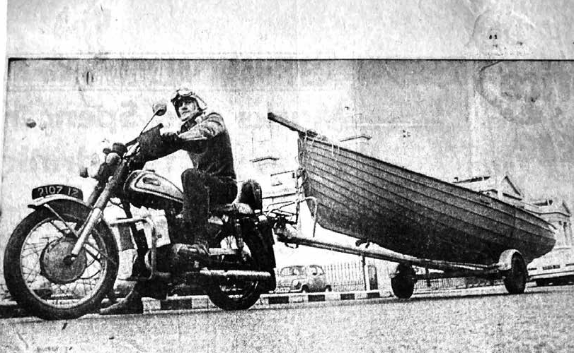
And...
Who might
this be?

Post your guess on our Facebook page
(Hint: He is an ICC member)

An uneventful week in Scotland

by Peter Mullan

The trip started at Quoile with my brother and my friend Brian; except Brian was playing golf and couldn’t do the trip to Bangor.
There was no wind for the uneventful sail to Bangor except we met a fisherman and bought two lobsters for a tenner. To find out how to cook them, we stopped into a very sunny Donaghadee (Hope Street). Tony (my predecessor as ICC subscriptions secretary) lives there. He came down to meet us. I gave him a lobster and he gave me cooking instructions. We left and as we passed Governors Rock on Donaghadee Sound, I dipped a big saucepan in the sea, dropped the lobster into the saucepan, brought it to the boil, and then changed

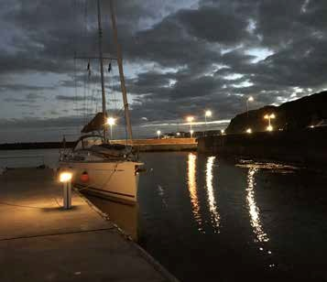
the water for cold fresh water. How simple. Dinner was lobster salad in the marina.
Day two was an uneventful sail towards Ballycastle. We made such good progress, that we just went on to Gigha. The big event in Gigha is always a superb meal in the Boathouse. A good walk to work up an appetite is essential. This we did. On the way back we found the tiny note on the door. Chef had been bitten by something. He had had a bad reaction and had to be taken to the hospital in Oban. There was no Boathouse event. Thankfully we had brought nice food from home in the freezer. We retired to the Gigha hotel bistro for a nightcap. A little single malt from Jura. Two actually, as a wee bird never flew on one wing.
There was wind the next morning for our uneventful sail north. We sailed into the little anchorage in the McCormack Isles. It was lovely. We blasted across to Lussa Bay on Jura at maximum speed. Great fun. Weather grey so we passed on up to Craobh Haven. The next big event planned was a steak in the Lord of the Isles pub. Great last time with Stanton and Pat Adair but
Scottish pubs couldn’t get staff. No food. A non-event. The chandlery was open, and many small issues were resolved. Another pre-prepared home cooked treasure was found in the freezer.
The weather forecasts from many websites were perused. They all said strong to very strong southerlies were coming. We set off for possibly Islay, perhaps Port Ellen.
It was all very uneventful, so we pressed on and arrived in Rathlin. No food in the pub, so we gathered all our breakfast provisions and enjoyed a full Ulster fry. My cousin Tom McLaughlin was tied up alongside in his
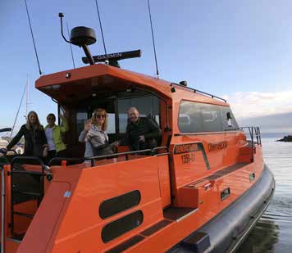
My cousin’s RIB
huge Redbay Rib. Redbay use this rib to service all their many customers on the west coast of Scotland. A mighty craft of which we were given the guided tour. Very impressive. Lovely quiet night. Uneventful.
Next morning, we set off south for an uneventful trip back towards Quoile. Not much to note except for the massive loud rumble off Garron head. I couldn’t work out what it was. The penny dropped. I had intended to anchor in Lussa Bay but had changed my mind. Sadly, I didn’t tighten up the anchor windlass. It worked loose and the anchor and all the chain disappeared over the bow. Thankfully the rope between chain and boat was tied on very well. Two of us managed to get it all back on board and we tied off the anchor properly. We intended to go into Browns Bay and anchor for coffee and a bun. The wind had piped up so that plan was abandoned. The southerly wind had arrived with a vengeance. A very long tack offshore and back in again made little progress towards Bangor but was good fun. The Bangor Regatta was in full flow. We called up and got a berth, even though they were very busy.

My sister-in-law Maree was very poorly in Ballymena. My daughter Barbara drove me up to see her and say goodbye. She passed away that night. Maree sailed with her husband Davey many times to Scotland from their base in Cushendall. So sad.
Forty knot winds in the forecast meant no return home for a while. But then a little window of opportunity arose if we left Bangor at six AM on Monday morning. Crew were mustered and away we went early. By lunchtime we were back at Quoile after yet another uneventful trip. A week after we left, we were home again.

2023 Tall Ships Voyages Awards
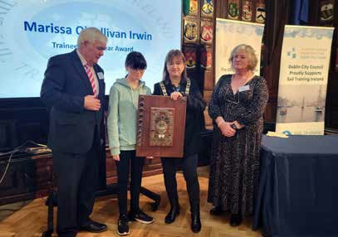
Trainees who made outstanding contributions to the Tall Ships voyages organised in 2022 by the charity Sail Training Ireland were recognised at the Annual Awards Ceremony at the Mansion House, courtesy of the Lord Mayor Caroline Conroy (on Saturday 28th January 2023).
The award winners were among the 546 trainees who sailed on voyages on tall ships last year. Since 2011, 3,000 young people from all backgrounds and abilities have availed of the opportunities provided by Sail Training Ireland (STIrl) to participate in training and self-development programmes. These are designed to offer a change in direction, perspective, attitude, and behaviour leading to self-confidence, motivation, and the acquisition of new skills.

Trainees include young people from residential care homes, Garda Diversion Projects, Youth and Community groups and Schools, drug rehabilitation programmes, asylum seekers, and young people with additional needs from across Ireland.
The highlights of Sail Training Ireland’s programmes in 2023 will include:
- Erasmus+ Youth Exchange between Ireland and Malta.
- Two STEM at Sea voyages incorporating science at sea training workshops.
- Thirty young people from Dublin’s North-East inner city participating as part of the Taoiseach’s taskforce NEIC project.
Trainee of the Year Marissa O’Sullivan-Irwin receiving the award from Lord Mayor of Dublin Caroline Conroy and Sail Training Ireland Chairman, Seamus McLoughlin
- Regional sail training schemes (funded programmes) in Drogheda, Cork, Dublin, Belfast, Wexford, and Waterford.
- Cross Border voyages including young people North and South.
- As part of the Ability Voyage project, several wheelchair users will go on board the Tall Ship ‘Tenacious,’ a ship built specifically to cater to those with disabilities.
The Government of Ireland (Department of Defence, Dublin City Council, and Dublin Port Company continue to support the charity in all that that they do.

Wanted for TCD Library:
ICC Annuals from before 1977

by Andrew Somerville
The Library of Trinity College Dublin currently holds a continuous run of the ICC Annual from 2012. I am donating my set of earlier volumes to the library, so that the TCD collection will soon cover all of the years 1977–2022, plus two earlier years: 1955 and 1956.
I’d like to see the TCD collection extended back to the earliest years of our Club. If any members have volumes of the Annual earlier than 1977 (except for 1955–56) that they would like to send to a good and appreciative home, they may contact me at rsomrvll@tcd.ie or +353 (0)86 805 4900.

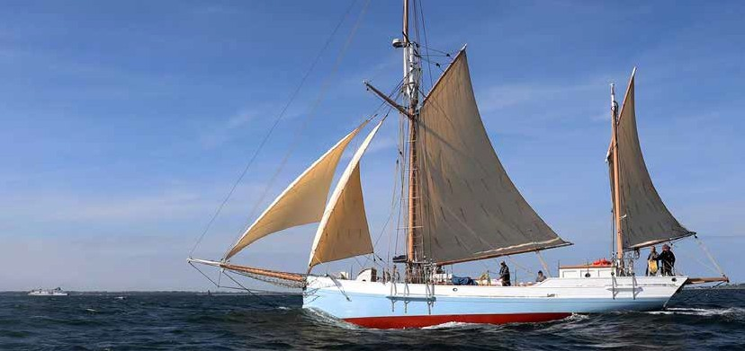Ilen sailing in Dublin Bay credit Dermot Lynch
Sailing Into Wellness
by James Lyons
Reflecting on 2022, Sailing into Wellness enjoyed an outstanding and active twelve months. We continue to progress in our community and recovery work while expanding our reach nationwide.
This was the year we took SIW on the road. Our mobile unit of two Hawk 20 trailer sailors, a van (kindly sponsored by ICC member Mark Whitaker), and amazing staff saw us bring our programs to 9 different locations both coastal and inland. This has allowed us to partner with a number of new community organisations working in additional needs, mental health, youth at risk, direct provision, and addiction recovery.
We are particularly proud of how our inclusion program has evolved. It is focused on helping those with additional needs. We operated in 5 locations and worked with dedicated support organisations.
As we emerge from COVID and reflect on the last three years, we can really see the essential nature of what we do. We are highlighting the advantages of sailing as a healthy, therapeutic activity which positively impacts the health and well-being of our communities. We are grateful to our clients for their time and commitment to the Sailing into Wellness program and are delighted to witness the positive impact our programs are delivering.
Looking forward to 2023, we are excited to be back on the road. Our mobile unit will be kicking off activities on Lough Derg this April. Added to the SIW fleet is the beautiful OE 38 Oelvira which our crew delivered from Finland to Kinsale in November & December! Of course, 2023 being Conor O Brien’s circumnavigation centenary we are particularly looking forward to voyaging the Irish coast on the AK Ilen. Hopefully, we will be sharing O Brien’s sense of adventure with all those who sail on her. The highlight for me personally will most certainly be the Ilen voyage to Madeira joining the Saoirse rally.
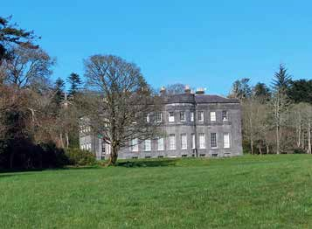
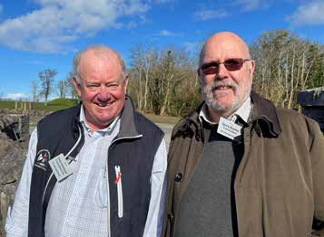

Lissadel House, which about 100 members visited during the ICC Annual Weekend
Page 30 ICC News, Spring 2023
Commodore Chris Otorowski, CCA Commodore David Beattie, ICC

A walk along the Royal Canal

by Alan Markey

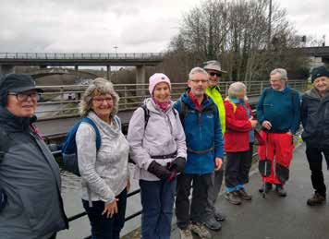
Despite the early start on the morning after the AGM, a dozen people turned out at the Convention Centre for the Eastern Region walk along the banks of the Royal Canal. As we set out northwards from Spencer Dock, we took a moment to admire the sculpture of local lad Luke Kelly. Unfortunately, this sculpture has been vandalised many times, but looked good on the day.
Then, it was on past the redeveloped docklands and the old inner-city neighbourhoods of North Wall and North Strand. All was well until we came to an unexpected barrier at Summerhill. There was a sign saying that the “Canal Towpath is closed” and this unwelcome news was enforced by very substantial fencing. I was mildly embarrassed because, on my recce about four weeks previously, nothing was amiss. The problem now was to determine how far this closure went. Nothing for it but a bit of street walking around Croke Park until we were able to re-join the canal at Binn’s Bridge on Drumcondra Road.
Within a few metres is the much-admired statue of Brendan Behan seated on a bench looking at a bronze blackbird. He was also a local boy, on account of his residency in Mountjoy Jail just across the canal, which led to the writing of Borstal Boy.
The canal bank is interesting here as a number of double-chamber locks come in quick succession as the level rises to Cross Guns Bridge, Phibsborough. The grey stone building towering above us on our left was the former Ranks Flour Mill now converted to apartments. From here on the feel changed as we gradually transitioned from city to country. Over the fields to the right we could see Glasnevin Cemetery and further along on the left was the old Batchelors factory.
Next stop was Broombridge where we found the plaque commemorating the Irish mathematician William Rowan Hamilton. While walking from his home at Dunsink to
Trinity College Dublin in 1843, Hamilton had a brainwave. He scratched his equation for quaternions* on the bridge in case he might forget it. His brilliant discovery is celebrated by mathematicians in a walk from Dunsink to Broombridge on 16th October every year.
We resumed our walk in light misty rain and were glad to take a break at a nice coffee shop at Ashtown. Suitably refreshed we changed to the south bank and continued in a rural setting until the Royal Canal is carried by aqueduct over the M50. It was amazing to stop and look down at the speeding motorway traffic. A little further on brought us to the 12th Lock where we admired the moored barges.
Some members of the group decided to bail out as we were beside Castleknock station while the rest continued on. The next stretch is interesting as it is the first part of the “deep sinking” where the towpath is high above the canal. It must have been a tough task for the construction team to dig such a deep cutting.
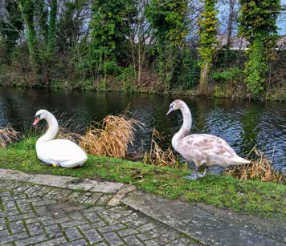
As we approached Coolmine crossing we heard the alarm sound for the level crossing, and without any discussion, all hurried to the station. The first train was a mainline train which did not stop, but the advice- panel suggested the commuter train would be along in 5 minutes. That sounded good.
To everyone’s amusement the Castleknock group were still waiting as we pulled in to Castleknock station. All together again, we headed back towards Connolly and reflected on a good day out.
*Hamilton defined a quaternion as the quotient of two directed lines in a three-dimensional space, or, equivalently, as the quotient of two vectors. Multiplication of quaternions is noncommutative.

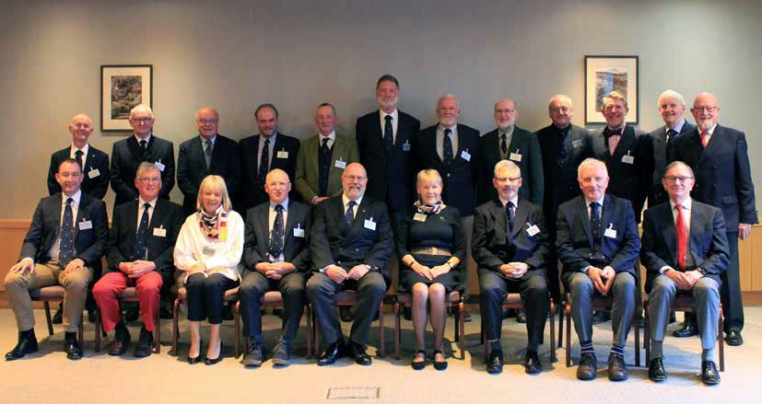2023 Annual Dinner Weekend, Sligo
2023-24 Irish Cruising Club Committee
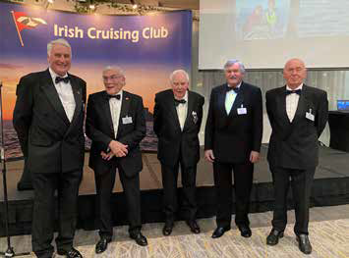


Former Commodores in attendance at the Annual Dinner: Peter Killen, Peter Ronaldson, Michael McKee,
Stanton Adair, and David Tucker
Winkie Nixon regailing the large attendance at the ICC Annual Dinner with stories about ICC members and their adventures after receiving the Fastnet Award (below)

Page 32 ICC News, Spring 2023
