To Seek and never to yield
by Vera Quinlan and Peter Owens

A family adventure throughout the Atlantic 2019 / 2020
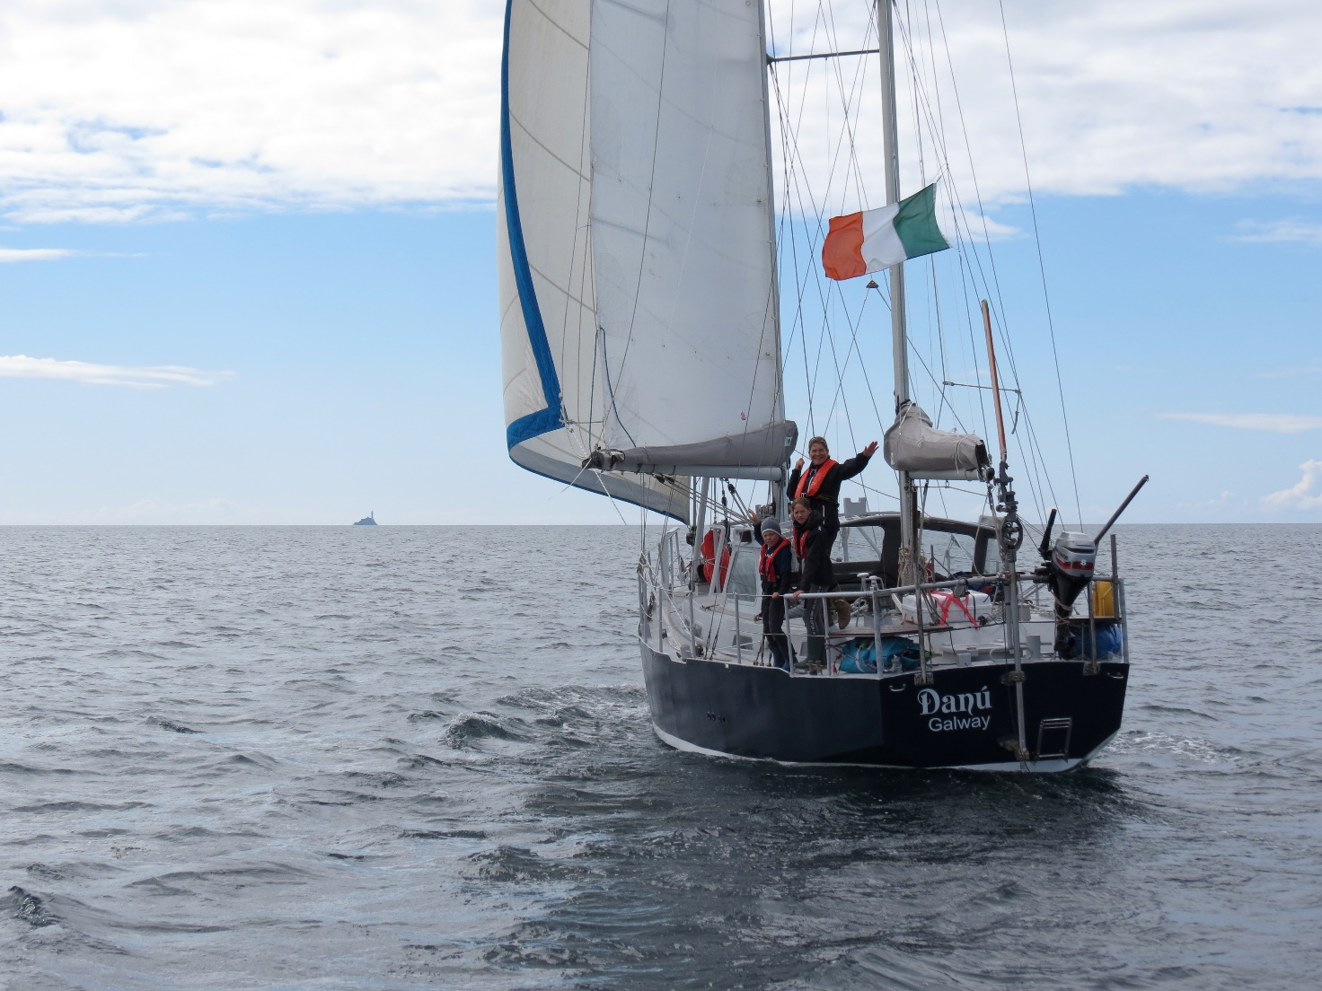Leaving Irish shores for the Scilly Isles
As the world began to go into shutdown, we were sailing up the west coast of Guadeloupe, with ideas of going to Montserrat for their annual St. Patricks day parade. News began to filter through about countries in Europe closing down so we made the decision to sail directly to Antigua. From a sailing point of view, Antigua offers many safe anchorages for all wind directions. If we were to be locked down, we reasoned that it should be there.
We managed to clear into Jolly Harbour customs, minutes before Antigua closed its customs office there. News filtered through of how countries were dealing with sailing yachts and it was clear that movement would be seriously restricted. We had heard of a sparsely populated island called Barbuda to the north of Antigua, surrounded by reefs and crystal-clear water so it made sense for us to sail there as soon as possible before being restricted to do so. We made the short 30-mile hop to Barbuda and dropped our anchor off a reef on its southeast side, called Spanish Point.

This was indeed a wonderful place to be. The water was so clear we could see our anchor dug in from the bow of the boat. There was little roll as we were protected from the Atlantic swells from the reef close by. Snorkelling was exceptional with a whole range of sea creatures to see. Sharks, eagle and stingrays, lobsters and a myriad of multi coloured reef fish were spotted on most of our dives. Sometimes we would snorkel two to three times per day. We got to know this little reef quite well, so well that we could return and visit the same marine creatures on different days. A day after arriving, the coast guard arrived and informed us that we were welcome to stay but not to leave as Antigua was in full lockdown with 24 hr curfew. We were now stuck on this island paradise for the long haul. Eight boats with sailors from France, Sweden, Scotland, South Africa, and the UK were anchored close by, many of which had families on board. As the days passed, we got to know each other well, and the kids spent their days in and out of the boats, messing about on sup boards and dinghies. There was a real sense of community; it felt like a mini commune at the edge of the world. As the days passed into weeks, food and water became an issue on Danú. For food supplies, an enterprising Barbudan resident would deliver to the beach after we sent a WhatsApp message detailing the food we required. He would arrive in a pickup truck, drop off the food on the beach and we would drop off the payment, adhering to social distancing as much as possible. It wasn’t cheap but it was a lifeline to us at this difficult time. We ran out of water after 2 weeks, but a Swedish boat nearby kindly let us fill our tanks by the can as they had a water maker onboard. Another lifeline for Danú and an example of the camaraderie between the cruisers at this idyllic spot.
Global lockdown had curtailed the cruising plans of nearly every boat out at this time. Our plan had been to continue north to the Virgin Islands and on to the Dominican Republic but this was simply not possible for the foreseeable future. So, we were stalled in Antigua and at this anchorage in Barbuda. And despite an abrupt halt, the flip side was we slowed down and really got to know a place for the first time in our voyage. We gained a lot of new friends, all of which we will keep in contact in years to come.
The lockdown enforced many changes on most sailors. Some were simply not ready to cross eastbound, many finding themselves shorthanded unexpectantly. Yachts were shipped home on large container ships while others engaged professional crew. On Danú, we always planned to sail to the Azores and beyond the archipelago to Ireland. Nonetheless, the Atlantic crossing ahead of us had a heightened sense of drama as when we left almost no countries (including the Azores) were open to visiting yachts. We returned to Antigua, started provisioning and kept an eye on the weather. On the 16 May 2020 we weighed our anchor and sailed for home from Deep Bay for our second family ocean passage.
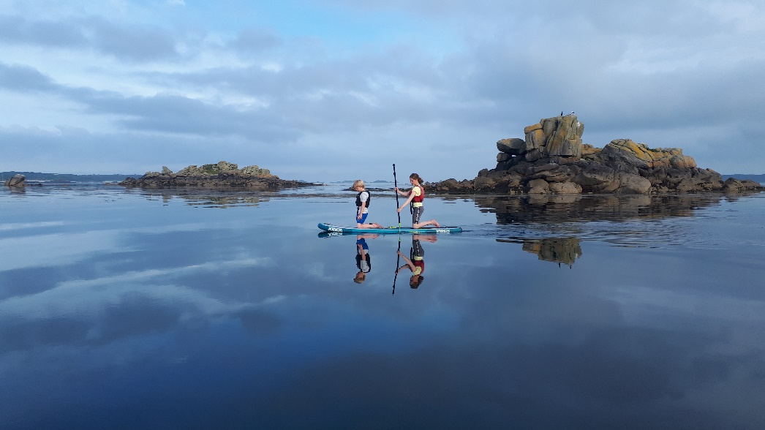
Paddle boarding in the Scilly Isles
A year previously, we had slipped our mooring in Parkmore Kinvara and headed out to sea. We had taken leave of absence from our jobs, the kids were out of school, the house was rented out and our ageing car had just been towed away by the scrappie. Heading out into Galway Bay on a 14-month cruise, mid-June 2019, was the culmination of many years of planning and building our 43ft steel ketch Danú up to be ready. A passage chart of the North Atlantic was fixed on the living room wall and each time we had a meal our eyes would glance over the places we could visit. The rough plan was an Atlantic circuit, sailing from Ireland to France, on to Spain and Portugal, Morocco, the Canaries and then to the Cape Verdes. From there we wanted to try something different by sailing to South America. Hence forth to the Caribbean and maybe as far north to the eastern seaboard of the US. We wanted now to show the kids something of this cruising life, an extended voyage to many different countries with ocean passages. They were at a great age; Ruairi was 9 and Lilian 11 at the time of leaving. But taking the kids with us this time brought a very different dynamic and amplified the responsibility.
After four nights in Dingle, and one in Crookhaven we made the jump to the Scilly Isles. This little archipelago was worth visiting with some great anchorages in crystal clear yet still cold water. A gale forecast prompted us to sail to Falmouth where we met with Vera’s sister, Sarah, and family. By 5 July we departed for France, making landfall in Cameret Sur Mer. We stopped at the Îles de Glénans, famed sailing school nestled in a small archipelago. The crystal-clear waters were perfect for the kids first snorkelling adventures, though marine life was minimal. From the Glénans, we made for Trinité Sur Mer. We ate out in a wonderful French restaurant for Peter’s birthday. However, the primary reason for visiting Trinité was to access the 6000yr old mehirs and stone alignments at Carnac. We left the racing yachts of Trinité and sailed on to the sanctuary of Belle Île, a beautiful island, very French, with some superb coastal walking. From Isle de Houat we sailed across Biscay to northern Spain, 315 miles. We made good progress with an average speed of 6kts; the seas confused and lumpy on our approach to Carino.

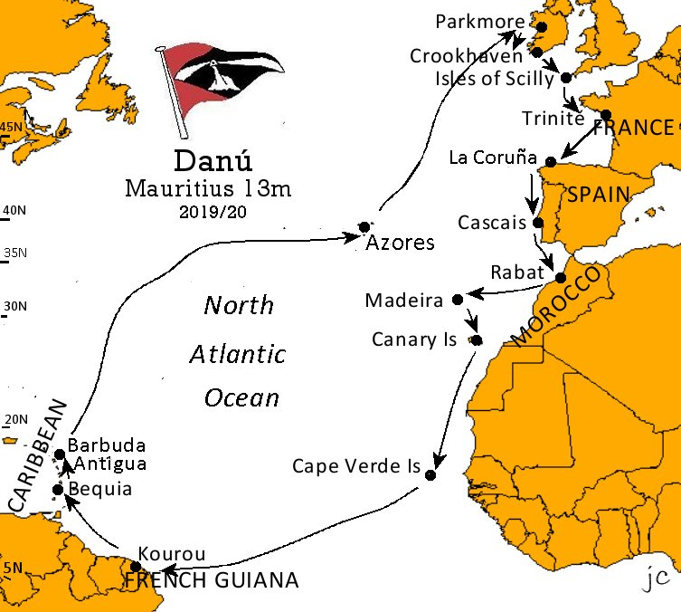
We left Sada by hire car and drove to the mountains for our first inland adventure. Asturias in Northern Spain has a beautiful mountain range, the Picos de Europa. There we walked and climbed, meeting up with old Irish climbing friends from years past, now like ourselves, armed with children galore. We stayed overnight in mountain huts, did a lot of walking and wrecked the kids. We returned to Sada two weeks later and sailed east to the cosmopolitan La Coruña and met with John Sweeney (ICC) and crew on the eve of their departure for Ireland. The town was abuzz with free concerts and we drank beer from plastic cups in the main square. Berthing fees at the Real Club Náutico Coruna was a shocker at €50 a night, but you can’t beat its location. However, we did linger in La Coruña long enough for Ruairi to buy a skateboard and Lilian to have a scooter accident leaving her with bad scrapes on her elbows and knees. Our sail to Muros was memorable for dumping 350L of fresh water into the bilges after a pipe ruptured. We visited several other classic spots of the Rías such as the Arousa, Pobra de Camariñal (and the lovely Rio Pedras swimming holes), Isla Ons and the Ría de Vigo, and on to Baiona. There we met the first of our Atlantic cruising boats, the French catamaran Boomerang II sailed by Stephane and Genevieve along with their two children. On the 21 August, we made a long jump to Cascais, anchoring at 2300 in 25kts of breeze, and from there on to Portimao four days later.

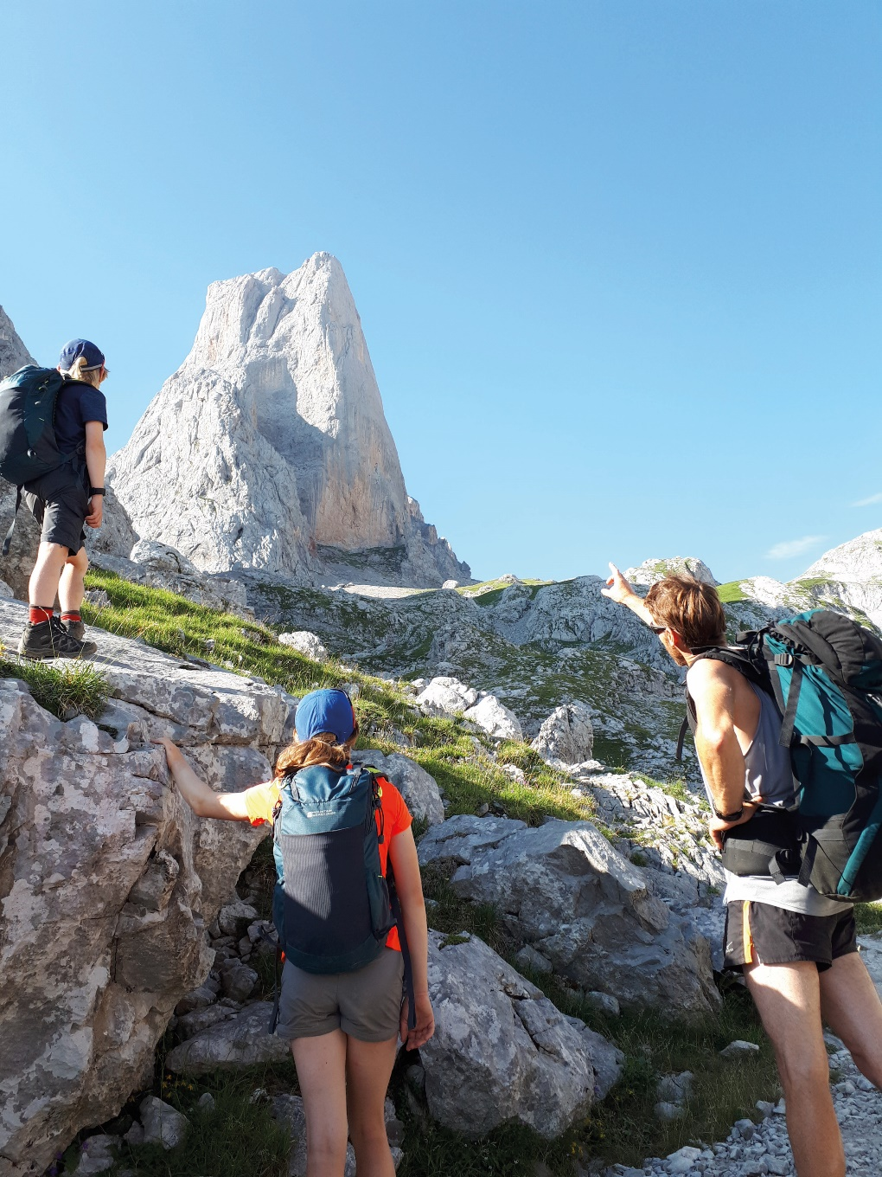
Remembering Naranjo de Bulnes, Picos de Europa
It took three days to sail across the straights of Gibraltar to Rabat in Morocco. Dodging plenty of ships in the first part of the passage, we had a mixture of sailing and motoring in good weather. On the third night, at the 1000m contour, we had to steer delicately through a multitude of small fishing boats with adjacent nets marked by flashing beacons. We ran goose-winged as close as we could, preferring sail over engine with so many nets. On the AIS we spotted a yacht at 0 kts, having got fouled. In the dead of night, Moroccan fisherman were heard on the VHF, calling and whistling to us yachts as we passed by, sometimes with menacing language, their idea of fun. Through the morning haze the coastline of Morocco came slowly into view. Swell can affect the entrance to Rabat and when it’s over 2m, yachts are advised not to enter. A pilot boat was sent from the marina to guide us through the unmarked channel, with a dogleg and breakers to negotiate at the entrance. Even on this calm morning, there was white water. The magnificent ramparts of the Kasbah les Oudaias swept down to starboard as we entered the Bouregreg river. This was a step back in time and a distinct change from European waters. Lavishly coloured fishing boats lined the shore and single oared ferry boats plied back and forth in front of us as we made our way upriver. Wide-eyed we took in the sights and sounds. Alongside the quarantine dock, we waited for hours, sweltering in the Moroccan heat. Police and Immigration boarded, all done in a cordial yet unhurried manner. To the kids delight a team of sniffer dogs were led towards Danú but unhappily for their trainers they were repulsed by our guard rails. It would have been interesting to see them in action. At 12 noon we finally tied up at the Bouregreg marina, tired and sweaty but happy to be in North Africa once again.

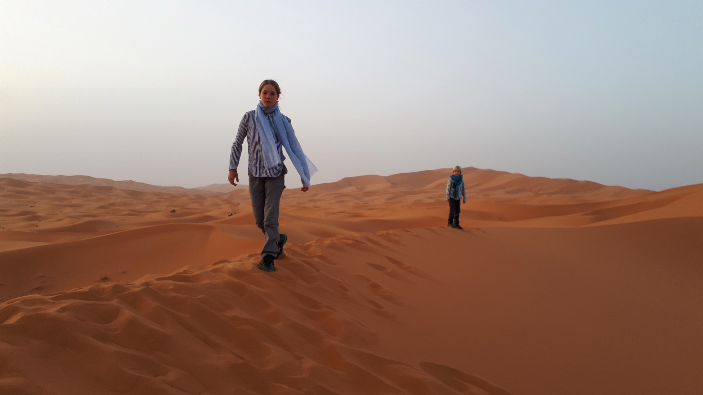The dunes of Merzouga
Three weeks were spent in Morocco. Leaving Danú safely tied up at the marina in Rabat, we took a train to Marrakech and from there by bus to the Q’uallat M’Gouna. This dusty town was the jumping off point for a six-day trek through the Jebel Saghro in the Atlas Mountains. For this we hired a guide, and two muleteers with mules. The Saghro are a lesser-known range in the Atlas, being lower in altitude but making up for that by its remote feel. The kids carried their own day packs with water and snacks. The adults a bit more and the mules the rest. Amazingly the kids kept going on with gentle encouragement at times. Over the 6 days we walked 150 km through a variety of landscapes, camping every night.
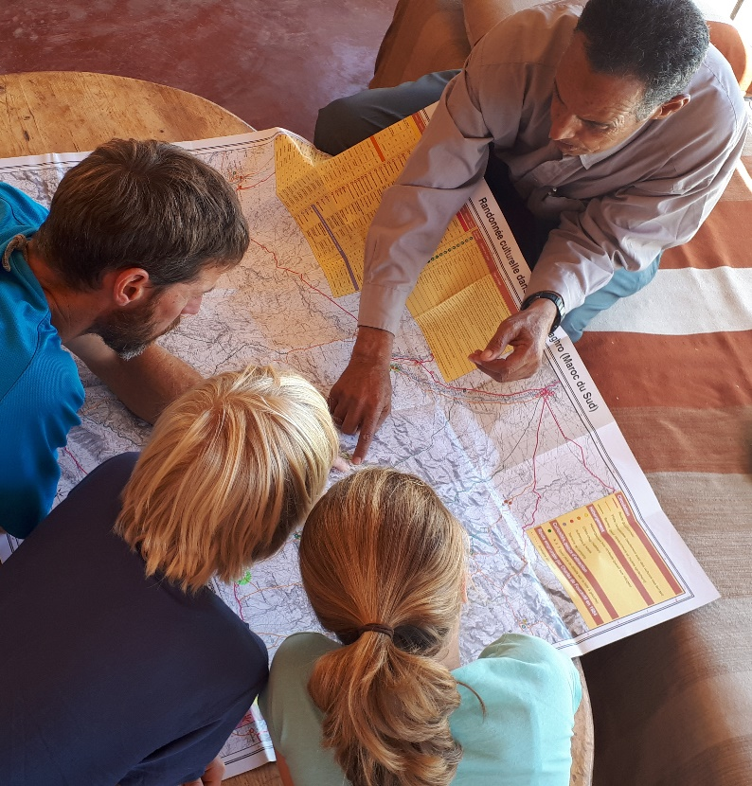
The scenery slowly changed from rocky mountains into desert, an incredible geography lesson. The destination and end of the trek was the exotic palmerie of N’Koub. From there, Lilian and Ruairí, our ‘trip advisors’, requested that we ride camels through the Sahara (not recommended by Peter) and camp out in the dessert at Merzouga. Following this, a variety of means of transport brought us to Er-Rachidia and after that an epic 14-hour bus journey back to Rabat. Morocco did not disappoint from a cultural experience. We were left with many great memories but we were happy to be opening up the hatches on Danú once more and to ready ourselves for our next passage.
Hurricane Lorenzo was due to kick up a swelll which would close off the exit from Rabat. So, the decision was made to depart Morocco on 22 September.
Planning the trek with guide Hamou Ait Lhou

Formalities were cleared in two hours with more dogs, a police check and our passports stamped. With a full main and genoa set, Danú was sailing at 6kts in a steady north wind. Three days passage took us to Porto Santo of the Madeira group. First looks of Porto Santo were not promising but we grew to love the island. Highlights were €6 a night berthing (including showers and water), good provisioning, an incredible 14 km beach, a high pier off the prom for jumping and some great walking. Here we met many other yachts planning to sail the Atlantic circuit, some of whom became firm friends. Some very sociable bbq’s later we tore ourselves away and departed for Maderia. Our first stop was the dramatic anchorage of Bahia de A’abra. Here we stayed only two nights, the roll eventually getting to us but the snorkelling and walking in the surrounding area was fantastic.
We departed Madeira in very gusty conditions and the first 24 hours was the most challenging sailing since our departure from Ireland. Two days later we anchored at Corralejo, Fuerteventura. This town is all about surfing and kiteboarding, so we took a class and bought a board. Ruairí excelled and made it look easy. The Canaries never lack for wind and with full sail we made good way to Tenerife, the mountainous view of this spectacular Island coming into view through the morning haze. The marina of Santa Cruz was packed at this time of year, so Danú had her first stern-too berth, interesting manoeuvring a heavy boat with cross winds and no thrusters but all was good with many lines and a few helpers onshore. We hired a car for three days for climbing and surfing; highlights included rock climbing above the clouds on the slopes of Mt Teide and surfing until dark in Puerto de la Cruz. We met with the Minogue family from Kinvara at the San Miguel Marina in the south of Tenerife. Conor, Breda and boys Micheál and Tomas, chartered a yacht for a week and without delay we sailed to San Sebastian on La Gomera. Many fine lunch spot anchorages were visited, and walks taken in the forested interior.
A fresh northerly wind brought squalls and rain for the first 24 hours on our passage from La Gomera to Sal, Cabo Verde. We caught our first dorado on day 2, making a fine meal with veg and rice. The wind increased steadily over the first two to three days and seas began to build to about 4-5m. By the end of day 3 we experienced gusts over 40 kts, these conditions lasted until day 5. We made steady progress under a small headsail alone, Danú surfing steadily towards the Cape Verdes. On the 11 Nov we could raise the main again with 3 reefs and by mid-morning we spied the island of Sal through the haze. It was a fast ride down with many yachts sustaining damage due to the conditions.

Palmeira, the main anchorage on Sal, was crowded with cruising yachts and it was difficult to find a space. This was however a lively and bustling place, and we were enthused to be in the Verdes again. We surfed at the southern end of the island and swam with lemon sharks. Getting around the island is a fun experience, flying along sandy highways in the back of a pickup. We sailed on to Isla Sal Rei on Boavista, 40 miles south. Here, Christopher Lacy, Vera’s godson joined the crew. Boavista has a very different impression to Sal, nice beaches and a great surf break close to the anchorage. Ruairí and Chris told of surfing with turtles one day. Unfortunately, the anchorage at Sal Rei is influenced by swell which increased daily until it became uncomfortable. With the reef breaking heavily not far from us, we began to feel uneasy so we sailed overnight to Praia on Santiago to clear out. Arriving on a Friday, we were informed we had to wait till Monday to complete the formalities. The police were far from helpful and told us that yachts were not welcome in the harbour; they could not control the security. They took our papers though, so we were stuck for the weekend. A yacht next to us told stories of theft and damage in Praia and on the nearby island of Fogo, prompting us to take the dinghy up at night. The highlights are few in Praia, but the chaotic fish market is a wonder to behold. Still we were happy when we got our passports stamped and left straight away for Brava the westernmost island of the group.

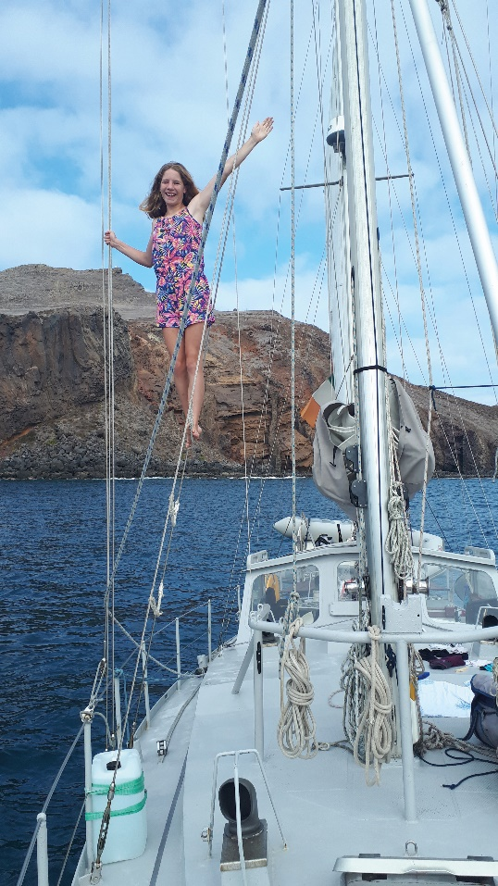
Passing by Fogo (the ‘Island of Fire’ with an active volcano) at night, we continued on to the Bahia Ferreiros at the south of Brava. The deep narrow inlet is a wonderful anchorage, with clear water and excellent snorkelling. We were able to fill our tanks with good water here, carrying jerry cans and 5L bottles down the cobble beach and into the dinghy. It was a heavenly anchorage, to us. Isla Brava has remained similar to what we found there 15 years ago: remote, friendly and unspoilt. The anchorage at Faja, a few miles to the west, was still as beautiful as we remembered, with only one other yacht there. This time, a swell was present making the dinghy landing with 5 of us, a choreographed affair.

We took a cab to Vila Nova Sintra for last minute supplies. The town is nestled in the mist-shrouded mountains of the interior, known for its flower-filled gardens. Back at Faja, we sipped cold beers and contemplated the next part of our journey, our Atlantic crossing to French Guiana.

The morning of 29 November was marked for two reasons; first we had Bacon Butties and eggs all round and the second was following breakfast we upped anchor and sailed west. This passage would take us 14 days, dipping down to 5˚22’N, passing through long sections of squalls with intense rain and electrical activity of the ICTZ. None of this is detailed on Predict Wind or any other weather site for that matter. We hadn’t yet sorted downloading gribs at sea so instead texted our position to Fergus and Kay Quinlan (ICC) every two days. Fergus and Kay would then send a brief forecast for our position for the upcoming few days. Always East, always F5. The reality was somewhat different at times but in the norm, we sailed with a poled-out genoa and a goose-winged main. On day 4 we landed a huge Wahoo, Chris’s patience with the line paying off. Later that night, the electrical activity we were seeing in the distance closed in, a huge strike hitting water just off the stern. We were running ‘dark’ at that stage, all electrics disconnected, lights off, sat phone in the pressure cooker. For such a strike to hit the water so close was amazing and the phenomenon was incredible to watch. Vera’s face turned temporarily ashen as she was on the aft deck at the time. By this time, we had settled into the rhythm of a big ocean passage. Baking bread became a ritual with each loaf improving on the last. Kids did school in the mornings and this somewhat noisy affair could be difficult for those just after the night shift. Board games or poker tournaments filled the afternoon hours. Working the boat and fixing things filled in the rest of the time. A new night shift and the process would start again, every day closer to our landfall.

On Day 8, mid-Atlantic, we deployed an ‘Argo’ float, a profiling device that measures temperature and salinity from 2000m to the surface at regular intervals and then, via satellite, transmits the data back to the Marine Institute in Galway. Way back in March we collected the float from the Marine Institute and agreed to take part in this global project for understanding climate change. We were to deploy mid ocean, the first float in that area by Ireland to date. With some apprehension we followed the pre-deployment procedure – would it still work after all this time? The mini-sub sprang to life and we carried it like a new-born to the aft deck. Lilian and Ruairí gave a speech on camera to send back to their school friends back home and at position 9˚16’N, 40˚04’W we pitched the float into the sea. We are very proud that the float did work and is currently reporting data back to the Marine Institute which it should do for a period of four years. Days 10 to 13 brought us rough conditions, cross swells, soul sapping counter currents and the feeling like we are in a washing machine. Seas were no more than 3m, winds 20-25kts at times. Sometimes we were making 3 kts, with 2kts contrary current, sometimes back up to 6kts. At 0800 on the morning of 12th of December, we dropped anchor in the murky waters of the Isles Salut, 1,789 nm sailed from Brava. Lots of hugs and jubilation on board and messages sent to family.

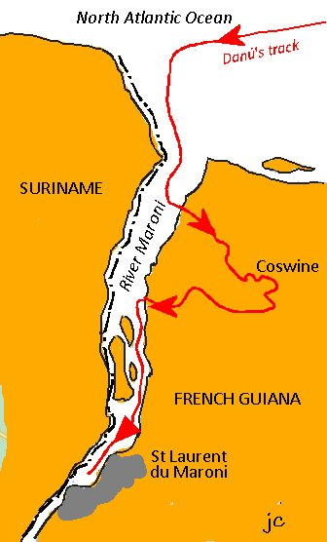
The islands were made famous by the book ‘Papillon’, and described horrific tales of life on the French penal colony. We were too excited to rest so we eagerly got the dinghy ready and explored the islands that afternoon. It was fascinating to walk through the relics of that bygone era (though not that long ago – the prisons on the Salut islands were only decommissioned in the 50’s). To the delight of the kids, large numbers of tortoises and Capucin monkeys were living on the islands. The Gendarmerie stopped by, checking our papers. We were to visit them again in Kourou. After a few days at Isle St. Joseph, we sailed overnight to the mainland and the Kourou river. In the darkness the depths shoaled quickly, a little unnerving. The channel markers led us across the bar, our sounder showing 0m in the muddy estuary for quite a few miles until we crossed into the deep river channel. We anchored in soft mud off the main town of Kourou in heavy rain. Ashore in Kourou, we found a large mix of nationalities living in this strange place. The town itself is unremarkable except that the European Space Agency launch site is close by. A Soyuz 10 launch planned for 2 days’ time was the reason for us being there. After a few false starts, the launch went ahead, Soyuz blasted into space. We saw a few brief glimpses through the clouds at 5am, the roar of the engines heard though the launch pad was 20 miles away. We were beginning to see why the French sent their convicts here–it rains hard and continuously, and the humidity was 100%. Mosquito nets were a requirement from dusk on and we would be eaten if there was a breach in our defences.

From Kourou, we sailed westwards with a fantastic Guianian current of 2kts making us too quick to arrive at the Maroni river entrance. We hove-to in rain showers and waited for dawn. The Maroni river forms part of the border between French Guiana and Suriname, reaching inland for 100 miles. Our destination was St. Laurent du Maroni, a large town 30 miles upriver, but first we took a detour up a tributary to the Amerindian village of Coswine. This jungle river was navigable for 15 miles and gave us a thrilling experience. We anchored opposite the village in a strong tidal flow, but with excellent holding. The village itself was built on an island, the only access by fast pirogue. As night fell, the sounds of the jungle came alive in the still air. Here we had a huge sense of being ‘off grid’, a place few sailed to. The next morning, we continued upriver, the branches of the trees almost clipping the spreaders at times. Danú motored slowly through, all of us lost in wonder at where we were sailing through. We regained the main river and sailed on to St Laurent, picking up a mooring buoy belonging to the ‘St Laurent Yacht Association’. Across from where we lay, the imposing walls of the Camp de la Transportation enclosed the site where convicts first arrived from mainland France. It is here that Papillon stayed

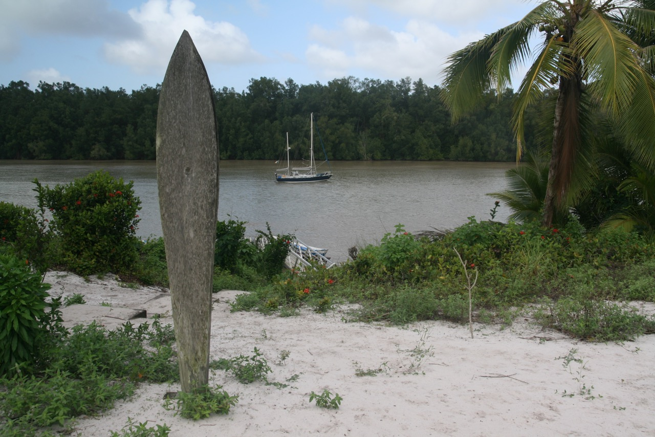
Anchored off Coswine, Maroni Tributary, French Guiana
for some time and the pages of his book came to life as we viewed this from our deck. It still rained profusely, the mosquitos never let up and we joked that we would never complain of Irish weather again. The dinghy filled so much one day that Ruairí had a bath in it. We celebrated Christmas at St Laurent; and Santa did get our GPS position. With ship procurement on festive overdrive, we managed to source turkey and ham and all the trimmings for dinner on Danú, albeit French Guiana style.

On St. Stephen’s Day, we were off again, bound for the Caribbean. French Guiana was fascinating in so many ways but a tough environment to sail in. The kids wanted to swim, and we wanted blue skies so, a little earlier than planned, we made our way out the Maroni river and turned NW bound for the island of Bequia, in the Grenadines. Chris left Danú that morning, offering to help sail the German yacht Mika to Tobago. Our passage to Bequia was wonderful, reaching in NE swell with 2kts of current with us at times. We recorded 170 miles one 24hr period and the closer we got to the Caribbean, the better the weather got. Four days later we dropped anchor in the crystal-clear water of Admiralty Bay, the kids jumping overboard before the anchor properly set.
New year was spent at Bequia, our days spent messing about in the water and some great sundowners with crews we met again on this side of the Atlantic. Our kids met their friends again and were very happy. Our great friends Garry and Kirsten on Wandering Albratross, sailed direct to Bequia from the Azores. We had met on our previous transatlantic voyage and had kept in contact in the intervening years. It was a lucky stroke that our timing coincided once again. We sailed south for 5 hours to the Tobago Cays, famous for their reefs and marine life. Of the Grenadines, Mayreau, Canouan and Union Island were visited.

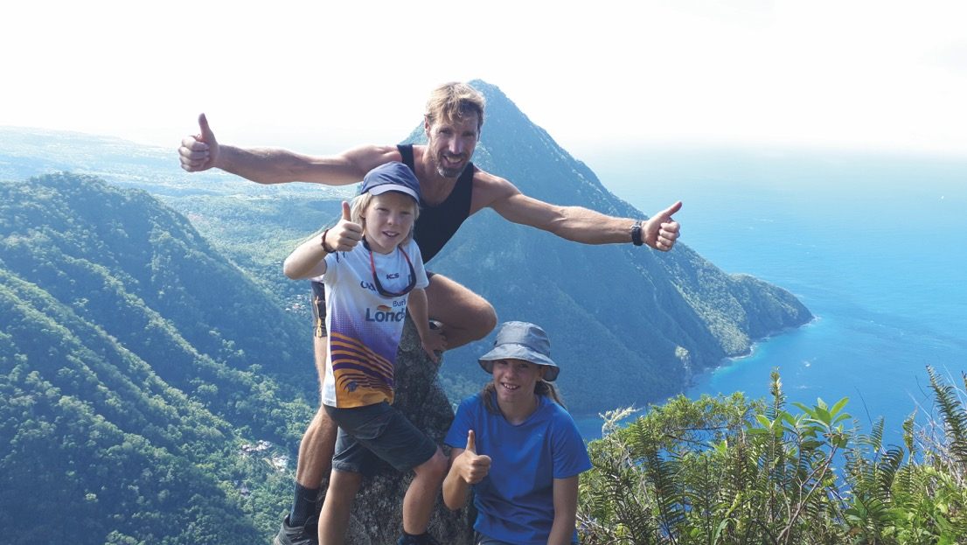
The top of Petit Piton, St Lucia
The Caribbean was everything we remembered but this time, many more yachts. No more the sole domain of long-distance cruisers, there were many charter yachts. The sheer numbers of boats at anchor must be putting pressure on these beautiful yet fragile ecosystems. You can always find quieter spots, but the best anchorages do fill up. The Caribbean has changed in other ways. 15 years ago, robbery and assault on boats was so bad on St. Vincent, that is was deemed unsafe to visit. Now, government policy has shifted toward eco-tourism and it has become safer to visit. We left Bequia and sailed to Vincent, anchoring stern to a large tree ashore in Walliabou Bay. This bay was one of the locations for the Pirates of the Caribbean movies and the kids recognised the locations straight away. We enjoyed Walliabou, the highlight being snorkelling off a bat cave a few miles south, reached by dinghy. From there we sailed to Soufriere, St. Lucia and climbed the Petit Piton. For this, we became local celebrities for a while, climbing the mountain with kids and no guide despite the dire warnings of certain death if we did. It was a fun day out; some climbing skills were useful at times and the view from the summit was outstanding.

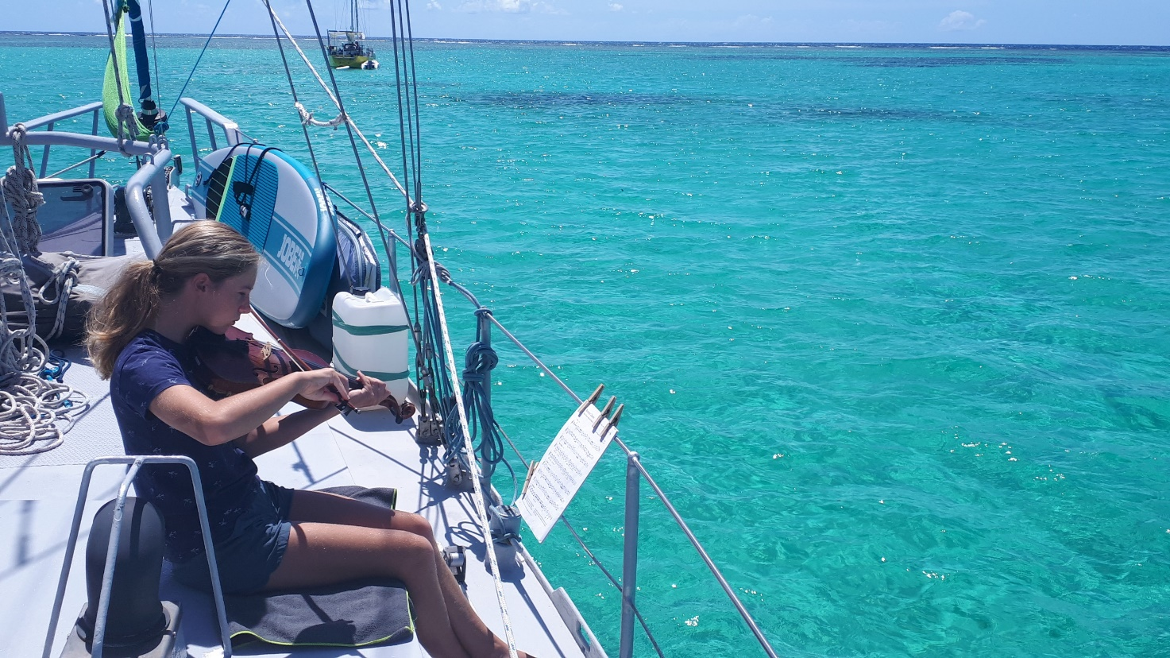
Violin practice
We spent two weeks at Martinique, mostly due to Peter and Lilian coming down with a bout of salmonella. Our time was spent between anchorages at Le Marin, St Anne, Fort de France and Mourne Rouge. Martinique is like a little piece of France set in a Caribbean backdrop. Provisioning was excellent but it didn’t feel like the real thing. We did climb up the highest point, Soufriere, a wet and windy affair. Weather was mixed during our stay there with many dull rainy days, and so, we departed French soil for Dominica on 17th February, laden with stores from Carrefour, and eager for somewhere new.
Dominica did not disappoint. This wonderful island was full of exciting places to visit and there were many great walks into the interior to explore. This we did without local guides and based on our own research. For most places you can get local buses or hitching to where you want to go. It takes a bit more time but if would have been prohibitive otherwise as the tour operators weren’t cheap. Highlights included ‘Champagne Bay’, known for a stretch of water filled with geothermally spread bubbles rising up though the sea floor; the 8-hour walk through rainforest and volcanic hillsides to the second largest boiling lake in the world; multiple visits to swim at the Chaudiere pools and the day long scramble up an overgrown trail through pristine rain forest to the summit of Dominca’s highest peak, Mt. Diablotin. Our first stop we took a mooring at Roseau, the lively capital of the island. The second took us to Portsmouth, a fine anchorage at the north end of the island. We did take one guided trip however, the Indian river at Portsmouth. Gliding along by oars alone our guide could pinpoint every bird and tree we saw. A very informative trip, but as usual the best travel experiences are ones you make yourself, that don’t cost anything, only effort and time. We spent two very enjoyable weeks at Dominica, unanimously our favourite island on the trip so far.
By the start of March, we were at the small islands of Les Saintes off the south of Guadeloupe. On the way to the anchorage at Terre de Haut, Peter spied a crag looking like a mini Fair Head, basaltic columns of 40m that could be climbed. With Kevin from German yacht Serenity (last met in Rabat) they climbed several routes, the hardest going at E2. Cruising certainly leads you into a diversity of situations. The day after we were sipping gin and tonics and real ice with Michael and Geraldine on Celtic Spirit of Fastnet (ICC). We continued on to Point-a-Pitre on Guadeloupe where we visited the incredible Museum of Slavery, surfed at Port Louis and of course climbed the island’s highest peak, another Soufriere, in wet muggy conditions. It was at Pidgeon island, the Jacques Cousteau marine reserve that we heard the world had changed and lockdown was coming.

Two months later, we departed Deep Bay Antigua, with a lovely send off from Peter and Wendy of yacht Henry (OCC) on a 2300 nm passage to Horta, Azores. We had a great start, reaching at 6kts along the west coast of Barbuda, and then we made the break, continuing out into the Atlantic. The first days’ sailing were great, if a little rough at times.
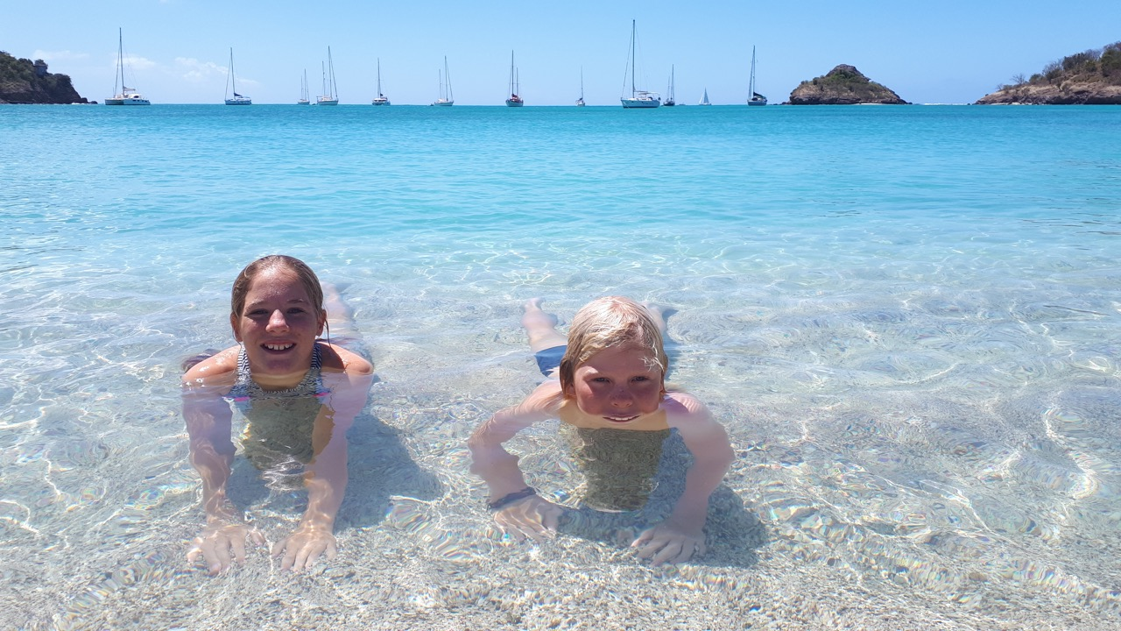
Spanish Point, Barbuda
This made Ruairí ill again but after only one patch he recovered well. Sunny days led to clear nights as we settled into the rhythm of a long passage again. Our watch schedule now included the kids, who would be on watch for specific periods aided by a parent ‘buddy’. In this way the ‘buddy’ would be fully geared up and ready to go if anything needed attention but could avail of extra sleep while Lilian or Ruairi was in the cockpit. They had strict instructions not to leave the cockpit unless going below and their lifeline always clipped in. The kids enjoyed the sense of responsibility this gave and took their watches very seriously.

Each morning we would send our position to Alex Blackwell (ICC) who had kindly agreed to relay this to the Predict Wind server. This updated our position on the OCC tracker, monitoring the progress of yachts as they made their way to Europe from the Caribbean. As the days passed the winds became lighter and from the NE. We sailed close hauled as much as we could until wind died completely leaving us in a mirror sea, one of the Predict wind forecast maps ‘blue holes of death’ as we fondly came to call them. We motored on, in search of wind, downloading the weather charts every few days. Our starting forecast had changed for the worse, the winds expected from the Americas not pushing the high eastwards and worse still, this zone of high pressure was to expand and stay still. There were some positives to this; a family of four swimming in 6,000m of perfect blue water; Ruairi’s’ ever improving bread; the endless calm sunny days. We pushed on northwards, sometimes getting periods of wind, albeit close hauled. Every day brought something new to fix. The autohelm failed due to corrosion at the terminals and the connections had to be rebuilt. Another plumbing failure caused the loss of 100L of our precious fresh water; it would have been worse if we hadn’t fitted the bilge alarm in the Rías. Ten days on we noticed a change in temperature, with the duvet jackets coming out at night. The wind always blew from the NE, exactly where we wanted to go. It was mostly light with not enough power to sail but sometimes short periods of stronger winds to 30kts were encountered. Our diesel situation at this stage was becoming worrying. We had brought an extra 100L in jerry cans for this passage giving a range of 550 nm. Our range was fast diminishing, prompting a close eye on the fuel.

By the start of June, all spare fuel was used, and we were down to a 20L ‘reserve’ can alone. Zephyrs of wind would come and go; we would try our best to sail when we could. To add to the insult, a 2kt counter current found us for 24 hours. On 5th June, with the forecast promising more of the same, we made the decision to motor sail for 6 hours more

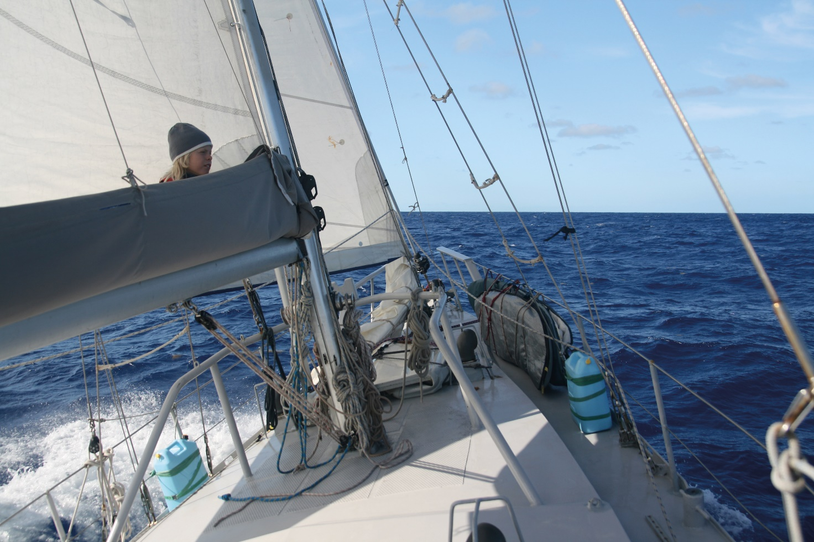
It took a little while but we eventually found Ruairi

and then shut down and wait for wind. We were literally making circles on a mill pond, when the luck of Danú changed. The container vessel Ileanao came in VHF range and we politely asked for fuel. There followed a fine example of comraderie at sea, the officer on watch organising an efficient fuel drop. Within a few minutes, the Ileanao changed course to intercept us and we were given instructions to motor alongside when she caught up with us. They had reduced speed considerably and were preparing 200L in 20L cans to be deployed on our signal. The enormous container ship came with 60m and just at the right moment, the bandolier of cans was dropped to the sea. Ileanao drifted on as we grappled the cans on board, a difficult hauling manoeuvre. On the aft deck, the whole Filipino crew of the ship cheered as we handled the fuel. With extra fuel we now had the ability to motor to areas of better wind to the north. However, we realised that we would still not make Horta so we resorted to tacking in very light airs; 1.5 kts in nearly the right direction was better than nothing. By 10 June, the wind backed to the north and we sailed direct to our waypoint, the first time in 20 days. The lights of Faial came into view and as we approached the island the wind died off again and the 20L reserve can was added. We entered Horta harbour with very little fuel, a close one. After 25 days at sea, our longest continuous passage yet, we dropped anchor amongst the 80 other boats on COVID quarantine in the harbour.

The boys from Peter Café Sport were alongside first with a hearty welcome and giving us the lay of the land. The police were next, all very cordial. Peter Sport come back and gave us a big bag of fresh goodies from Faial residents Gary and Kirsten of Wandering Albatross, last seen on Barbuda. The rules were firm, clear and concise; we were to remain on board, no socialising with other boats was allowed, food could be ordered via the Peter Café Sport guys via WhatsApp, fuel and water could be taken alongside a cordoned off end of the marina manned by security. With great timing from our part, a few days later, Azorean travel restrictions policy changed allowing cruisers ashore if they tested negative to COVID19. There’s no doubt that a lot work was done behind the scenes to make this happen and Jose Azevedo, port officer for the OCC had a lot to do with it. They called up the boats with children first, so with Lilian and Ruiari on board, Danú’s crew were first ashore to be tested amid some ceremony from the harbour authorities and making the local news on Faial TV. 24 hours later the results were back, and we could now officially clear into to European waters.

We spent a glorious week with the Wandering Albatross crew, staying at their house on Faial. The Azores invoked so many great memories from the first time we visited, and they really are a wonderful cruising ground, the islands so diverse in landscape and culture. We relaxed a lot on Faial, walking and swimming every day, often followed by beers and a bbq in the warm summer evenings. We took the ferry to Pico, climbing to its summit which as you know by now, is just something we had to do. We visited Sao Jorge and Terceira; on each island we hired cars and explored the inland landscapes and spectacular swimming holes. Five weeks were spent, as we felt, ‘on holiday’. Our last port of call was the small and friendly marina at Praia di Vittoria on Terceira. Time was moving on, and as for all voyages, our thoughts returned to that last passage homeward, to stocking, weather forecasts and departure planning.

On the 19 July, we motored out from Praia to the sounds of horns blowing and cheers from our new friends there. We had a few days under engine to escape the Azores high and then hoped to find favourable wind. As on the last passage, Lilian and Ruairi were to share the watches. The wind filled in at last pushing us away from the high, Danú goose winged in southerly winds. A Sei whale almost collided with Danú. With us sailing at 6kts, that magnificent creature, almost the length of our boat, crossed our bow with mm to spare. We were so close we could see clearly the Baleen. By the 25 July the swell had increased with gusty conditions giving us lots of sail changes. We were now back to 140 nm daily runs and spirits were high. Dark nights were lit up with fanciful bioluminescence and we piled on the layers for these hours. We fitted into the routine of family life at sea, a lot different to a crew of adults. The downloaded forecast next day showed an intense low to pass over our track, imminent. Winds first from the south increased to F5 making great progress for us initially. Backing to the SE and then quickly to the north, the barometer plunged to 980 and we were in gale Force 8 with 4m seas increasing. We hove-to for 12 hours and let it pass, the occasional roar of a big one rolling and breaking over Danú, foam streaming off the decks. By morning the barometer started to rise, and we got sailing again, conditions improving with every hour. But then a drop off in the wind and more motoring. We viewed the latest forecast; northerly winds veering easterly, sure to give challenging sailing. By now the temperature had plummeted and ocean blue had given way to grey steel Atlantic; familiar hues of home waters. The SE wind we had backed E and increased fresh with squalls of rain. As we closed in on the Aran Islands we realised we wouldn’t make Gregory Sound by sail and so bore off to the north, conditions deteriorating. The biggest battle of this year’s journey was our first 24 hours leaving and now closing in on the Aran Islands on our return. Danú finally pulled around the harbour entrance on Inis Mor and we come along side ‘Pylades’ and the Minogues on their yacht ‘Golden Harvest’; a fond welcome for us after 1,248 miles at sea.
During our Atlantic circuit of over 13,000 miles, we sought excitement and adventure everywhere we went, from the highest mountains to deep jungle rivers. We found out about many different countries and cultures. Perhaps the greatest thing we discovered was about ourselves and how we work as a family on a small boat.

And to follow the words of Ulysses, when planning this voyage and certainly on this voyage, there were times we did not yield.

Ulysses

